# **ABSTRACT:**

The integration of artificial intelligence (AI) technologies into healthcare systems has shown promising potential to enhance patient satisfaction, a crucial metric for assessing healthcare medical services in recent years. This investigation delves into the domain of Machine Learning to examine its effectiveness in enhancing patient satisfaction with medications, specifically by comparing prominent supervised machine learning models Multinomial Naïve Bayes and Random Forest Classifier.

The aim of this study is to assess how developing a Sentiment Analytical System using machine learning models can accurately analyse and interpret patient feedback to derive sentiment insights to optimize healthcare delivery processes. By conducting a comparative analysis between these models, the research aims to identify their individual strengths and weaknesses in capturing and analysing patient sentiments.

Through a comprehensive review of literature and theoretical frameworks, this research lays a foundation for understanding the importance of patient satisfaction in the healthcare service environment and the role of AI in augmenting this aspect. Following this, an empirical inquiry is carried out using actual patient feedback on medications (drugs) datasets to evaluate the effectiveness of Sentiment Analysis and its methodologies in extracting valuable insights from textual data.

These study results provide valuable insights into NLP’s capabilities in improving patient satisfaction on medications in healthcare settings. By contrasting these Sentiment Analysis methodologies, the research clarifies the intricacies of AI-driven methodologies in interpreting patient sentiments and provides recommendations for optimizing the integration of such technologies into healthcare systems.

Ultimately, this research aims to inform healthcare practitioners, policymakers, and AI experts about the potential of AI in enhancing patient satisfaction on medications (drugs) and fostering more patient-centric healthcare delivery models. The outcomes of this study have implications for the advancement of AI-driven solutions in healthcare and underscore the importance of leveraging innovative technologies to meet patients' evolving needs and expectations.

# **CHAPTER ONE**

## **1.1 INTRODUCTION:**

In the contemporary landscape of healthcare, patient satisfaction is paramount, driving efforts to optimize therapeutic outcomes and enhance the overall patient experience. Patient satisfaction is a multifaceted concept reflecting the extent to which patients are content with the healthcare services they receive, encompassing various dimensions such as quality of care, communication with healthcare providers, accessibility of services, and the overall healthcare environment. It is not merely a measure of the quality of care but also an indicator of the effectiveness of the healthcare delivery system from the patient's perspective (Donabedian, 1988).

In recent years, there has been a need for a more sufficient way of analysing patient feedback because the amount of patient reviews data increases as time unfolds. Sentiment analysis, a subfield of natural language processing (NLP), has emerged as a potent tool for understanding patient perspectives by analysing textual data such as reviews, feedback, and social media posts. The application of machine learning techniques to sentiment analysis enables the extraction of meaningful patterns and insights, thereby facilitating improved patient-centric drug administration strategies (Zhang & Zhang, 2019).

## **1.2 BACKGROUND OF THE STUDY**

NLP, a subfield of artificial intelligence (AI), focuses on the interaction between computers and human language. It enables machines to understand, interpret, and generate human language in a way that is both meaningful and useful. Key NLP techniques used in sentiment analysis include text preprocessing, tokenization, part-of-speech tagging, named entity recognition, and syntactic parsing (Jurafsky & Martin, 2020). Text preprocessing involves cleaning the data by removing noise such as punctuation, stop words, and irrelevant information. Tokenization splits text into individual words or phrases, while part-of-speech tagging identifies the grammatical role of each token. Named entity recognition helps in identifying and classifying entities like drug names, symptoms, and patient demographics. Syntactic parsing analyses the grammatical structure of sentences to understand the relationships between words.

Machine learning (ML) has revolutionized sentiment analysis by providing algorithms that learn and predict from data. The two machine learning classifiers used in this research are Multinomial Naive Bayes (MNB) and Random Forest (RF). MNB is a probabilistic classifier based on Bayes' Theorem, particularly suited to discrete data. It assumes that the presence of a particular feature in a class is independent of the presence of any other feature (conditional independence). In sentiment analysis, MNB works well with text data by leveraging word frequencies to predict the likelihood of a particular sentiment category (e.g., positive, negative, neutral) (Rennie et al., 2003). Conversely, a Random Forest Classifier (RFC) is an ensemble learning method that constructs a multitude of decision trees during training. The output is the mode of the class (classification) or mean prediction (regression) of the individual trees. RFC is robust to overfitting, handles large datasets with high dimensionality, and provides high accuracy in sentiment classification tasks (Chen & Guestrin, 2016).

Multinomial Naive Bayes classifier is a probabilistic model that is particularly well-suited to text classification tasks, including sentiment analysis. This algorithm is based on Bayes' theorem, which applies the principles of conditional probability to predict the likelihood of a given sentiment category based on the presence of certain words or features in the text (Rennie et al., 2003). The "multinomial" aspect of the model indicates that it is used to model discrete features, such as word counts or frequencies, which are common in text data. The Naive Bayes classifier assumes independence between features, which simplifies the computation and makes it scalable to large datasets. Despite its simplified assumption, Multinomial Naive Bayes has demonstrated strong performance in various text classification tasks, including sentiment analysis, due to its efficiency and effectiveness in handling high-dimensional data (McCallum & Nigam, 1998).

On the other hand, the Random Forest classifier is an ensemble learning method that constructs multiple decision trees during training and outputs the mode of the classes (classification) (Breiman, 2001). Each tree in the forest is built on a subset of the data and a subset of features, introducing randomness that helps to reduce overfitting and improve generalization. In sentiment analysis, Random Forest classifiers can handle complex interactions between features and are robust to noise in the data. One of the key strengths of Random Forest is its ability to capture non-linear relationships and interactions between words in the text, providing a more nuanced understanding of sentiment compared to simpler models. Additionally, Random Forests offer feature importance scores, which can help identify which words or phrases are most indicative of patient sentiment (Liaw & Wiener, 2002).

The integration of sentiment analysis into healthcare systems is revolutionizing patient satisfaction with pharmaceutical treatments by leveraging machine learning techniques, specifically.

Multinomial Naive Bayes (MNB) and Random Forest (RF) classifiers. Pharmaceutical companies can also use sentiment analysis to gather feedback on existing drugs, driving improvements in drug formulations, and gaining a competitive advantage (Garg & Rana, 2022). Despite its promise, implementing sentiment analysis in healthcare involves challenges such as ensuring data privacy, interpreting contextual nuances, and mitigating algorithmic biases (Wang et al., 2020). Addressing these challenges is crucial to realizing the full potential of sentiment analysis in enhancing patient satisfaction and optimizing drug-related experiences in healthcare settings. (Nguyen & Shen, 2018) Overall, the integration of sentiment analysis through Multinomial Naive Bayes and Random Forest classifiers represents a transformative approach to improving patient satisfaction, offering a powerful tool for understanding and responding to patient feedback in the pharmaceutical domain.

## **1.3 PROBLEM STATEMENT:**

Understanding and interpreting patient’s reviews on drugs reveals that some drugs prescribed for patients react negatively to them thereby making patients not to be satisfied with the treatment administered to them. Leveraging sentiment analysis on patient reviews on drugs has increased the researcher’s attention in recent years thereby making them to explore methodologies and approaches to interpret, understand and further enhance patient satisfaction on drugs. However, existing machine learning models and algorithms fall short of accurately classifying these patient reviews, as the algorithms are too complex to perform, and have low performance when applied to patient reviews.

For example, using Random Forest Classifier, a machine learning classifier that is robust to noise, reduces overfitting compared to decision trees model. The gap with this library is that it may still overfit if not properly tuned and it can be computationally intensive with many trees.

Another example is using Decision trees: This is another type of supervised machine learning model that is easy to interpret, visualize and requires little data preprocessing. The gap with this machine learning model is that it is prone to overfitting especially with deep trees and it is sensitive to noisy data.

Furthermore, using Multinomial Naive Bayes which is a type of Naive Bayes that applies probability in making its assumptions. It is fast especially when trained with large datasets. Its gap is that it is sensitive to zero probability.

Considering all these limitations, there is a need to develop a more accurate way of classifying patients' reviews on drugs.

**1.4 ECONOMIC IMPACT**

Implementing sentiment analytical systems in healthcare, particularly to enhance patient satisfaction with pharmaceuticals has substantial economic implications. Machine learning techniques such as Multinomial Naive Bayes and Random Forest classifiers can revolutionize how pharmaceutical companies, healthcare providers, and insurance companies interact with patients and manage drug-related data, potentially leading to significant cost savings and economic benefits. One of the primary economic benefits of sentiment analysis in healthcare is the optimization of drug development and marketing strategies. Pharmaceutical companies can utilize patient sentiment data to identify unmet needs, monitor drug performance, and understand market trends, enabling them to refine their research and development (R&D) efforts. This data-driven approach can reduce the costs associated with developing new drugs by focusing resources on areas with the highest potential for success and patient satisfaction (Bai et al., 2020). In addition to benefiting pharmaceutical companies, sentiment analysis can enhance the efficiency of healthcare delivery systems, leading to cost reductions for healthcare providers and insurers. By analysing patient feedback, healthcare providers can identify areas for improvement in treatment protocols and patient care, which leads to more efficient resource allocation and improved patient outcomes (Soni et al., 2019). This not only enhances patient satisfaction but also reduces the likelihood of expensive hospital readmissions and prolonged treatments. Another significant economic impact of sentiment analysis is its potential to reduce adverse drug reactions (ADRs) and associated costs. Adverse drug reactions pose a considerable economic burden on healthcare systems, with billions of dollars spent annually on managing these incidents (Kumar et al., 2020). By leveraging machine learning classifiers to analyse patient sentiments, healthcare providers can detect early signs of ADRs and adjust treatment plans, accordingly, reducing the incidence and severity of these reactions (Breiman, 2001).

However, implementing sentiment analysis systems in healthcare requires initial investments in technology infrastructure, data management, and personnel training, which may pose financial challenges for some organizations (Davenport & Kalakota, 2019). Additionally, ensuring data privacy and security remains a critical concern, as breaches could result in significant financial penalties and loss of patient trust (Bennett & Raab, 2017). Despite these challenges, the long-term economic benefits of sentiment analysis, including improved patient satisfaction, enhanced drug development, and reduced healthcare costs, make it a valuable investment for stakeholders in the healthcare industry (Amann et al., 2020).

Specifically, the new system will help the health care sectors to discover areas that need improvement, and this will further help in enhancing patient satisfaction.

## **1.5 RESEARCH QUESTIONS:**

The research questions include:

1. How do model performance metrics (e.g., precision, recall, F1-score) differ between the two machine learning models when applied to patient drug satisfaction analysis?
2. How do Multinomial Naive Bayes and Random Forest Classifier compare in terms of identifying sentiments in patient drug reviews?
3. What impact does hyperparameter tuning have on the performance of the best model?
4. How does the new system model performance matrices (accuracy) differ from other researchers’ models?

## **1.6 LEGAL, SOCIAL, ETHICAL AND PROFESSIONAL ISSUES:**

Having searched and selected a dataset that was relevant and ethically sourced. The sequential procedures involved searching open sources such as Kaggle for datasets relating to patient reviews and drug satisfaction, reviewing dataset descriptions, and ensuring they are ethically sourced with patient consent, downloading the dataset, and examining the data fields for an understanding of its structure and content. The dataset is licensed under a Creative Commons Attribution 4.0

International (CC BY 4.0) license. Which allows for the sharing and adaptation of the datasets for any purpose, provided that appropriate credit is given. Thus, the project will not need ethical approval because the study does not involve human participants. During the research, it was discovered that the dataset license was not on Kaggle. The researcher had sent an email to the dataset owner requesting a guarantee that the dataset is compliant with the research protocols of the university (See Appendix 13). The owner on Kaggle sent the researcher the link to where the license is (https://archive.ics.uci.edu/dataset/462/drug+review+dataset+drugs+com ). The researcher has also attached a screenshot of the license details in Appendix 14. Therefore, there is no need to obtain ethical clearance from the relevant authority. ECDA (Ethics Committee with Delegated Authority which functions as a sub-committee of the Ethics Committee) at the University of Hertfordshire.

## **1.7 PROJECT SPECIFICATION:**

This project focuses on applying sentiment analytical system in enhancing patient satisfaction on drugs which will classify patients reviews on drugs. It will develop two machine learning models from scratch leveraging on Feature Engineering (TF-IDF) to extract the documents and use of SMOTE, an oversampling tool to ensure that the class is balanced in order to bridge the gap of overfitting.

It will also compare the two machine learning models based on the metrics used. The two models are Multinomial Naïve Bayes and Random Forest Classifier. This project produces a framework which accepts patient’s reviews about drugs, it classifies and returns the sentiment of the review.

## **1.8 AIM OF THE PROJECT:**

The aim of this study is to build a sentiment analytical system that will enhance patient satisfaction on drugs using machine learning model.

## **1.9 OBJECTIVES OF THE PROJECT:**

The specific objectives of the project are.

1. To design and implement an algorithm that uses Spacy Python libraries to preprocess data and understand the data, for obtaining accurate analysable results.
2. To design and implement an algorithm that uses sentiment analysis on patient reviews on drugs to categorize the review into positive, negative, and neutral using the TextBlob python library.
3. To design an algorithm that trains the naïve bayes classifier and Random Forest Classifier from scratch and compare them based on their metrics.
4. To perform hyperparameter tuning, investigate and evaluate the metrics, and performance of the best model.
5. To compare the performance of the best model with that of other researchers’ models.
6. To design an interactive User Interface to enable interaction with the model using Python Flask for the Backend and using HTML and CSS for the Frontend.

## **1.10 STRUCTURE OF DISSERTATIONS:**

The overview of the dissertation is as follows:

**Chapter One:** This section is focused on introduction, overview, economic impact, ethical consideration, and dissertation structure making clear overview of the project.

**Chapter Two:** This section majorly is on the breadth of this research, review of related work and research gap.

**Chapter Three:** This is a material and methodology chapter that describes the technique applied for the project implementation and development.

**Chapter Four:** The chapter is configured for fact finding, comparing methods and results, system implementation and analysis.

**Chapter Five**: Summary, Conclusion and recommendation.

# **CHAPTER TWO**

# **LITERATURE REVIEW**

The review of existing literature plays a role, in laying the groundwork for this research project helping to identify areas for future exploration. It delves into the use of sentiment analysis to evaluate feedback on drug satisfaction shedding light on strategies employed including preprocessing methods with tools like Spacy and machine learning techniques such as Multinomial Naive Bayes and Random Forest classifiers. The discussion also examines how Spacy advanced preprocessing features could potentially improve the accuracy and performance of sentiment analysis algorithms by enabling text parsing and feature extraction (Honnibal & Montani 2017). Furthermore, it compares the effectiveness of machine learning models in categorizing sentiments expressed in reviews of drugs focusing on important metrics like precision, recall and F1 score that are crucial for assessing model performance (Liu et al., 2021). The review also touches upon the significance of hyperparameter tuning in enhancing model efficiency emphasizing its role, in boosting accuracy while simplifying model complexity (Bergstra & Bengio 2012).

## **2.1 BREADTH OF BACKGROUND RESEARCH**

The breadth of background research for applying sentiment analytical systems to patient satisfaction on drugs using machine learning models encompasses a wide range of disciplines and key concepts, which includes Machine Learning Models, Supervised Learning, Natural Language Processing (NLP), Sentiment Analysis Techniques, Multinomial Naive Bayes, Random Forest Classifier, Patient Feedback and Satisfaction Metrics, TF-IDF.

### **2.1.1 Machine Learning and Artificial Intelligence**

Machine Learning, a branch of Artificial Intelligence empowers computers to learn from data without programming. The main aim of Machine Learning is to enable systems to learn and make decisions based on data patterns (Saravanan et al., 2018). These models have gained popularity across sectors such, as energy systems, finance, and central banking. They excel in tasks. Have showcased enhanced accuracy, resilience, and adaptability by leveraging hybridization and ensemble techniques (Mosavi et al., 2019). In the realms of drug discovery and healthcare these models are increasingly being utilized to address challenges. They exhibit precision in predicting bioactivities, molecular properties, and drug classifications (Purwono et al., 2021). By analysing datasets from high throughput screening and medical records these models have the potential to streamline the drug discovery process and cut down clinical trial expenses significantly (Ekins et al., 2019). The field of sentiment analysis has been revolutionized by Machine Learning models enabling the extraction of insights, from volumes of textual data.

Machine learning models have made progress, in sentiment analysis in the healthcare sector. Hybrid and ensemble methods are enhancing the capabilities of these models across fields as they evolve. The accuracy, robustness, precision, and generalization abilities of machine learning models in energy systems have notably improved with the use of approaches. Hybridization has proven to be effective in advancing prediction models. Various types of machine learning algorithms exist based on their learning methodologies, including supervised, semi supervised and reinforcement learning which provide unique insights from patient feedback on medications. Ongoing research and development efforts are driving enhancements in sentiment analysis accuracy and efficiency offering insights for healthcare providers, researchers, and pharmaceutical companies. While machine learning holds promise for research further validation and refinement are essential for applications, in healthcare settings.

### **2.1.2 Supervised Learning**

Supervised Machine Learning (SML) is a branch of machine learning that utilizes labelled data to train models, for predicting outcomes on data. It involves linking input output pairs to deduce a function. The procedure encompasses data gathering feature extraction, model training and assessment. Its application spans across domains like image recognition, language processing and fraud detection. Common algorithms in learning include decision trees, forests, naive Bayes support vector machines and neural networks. Developing learning models encompasses theoretical and practical dimensions. An essential aspect of learning is the presence of training data that enables the model to understand the connections, between input variables and corresponding output labels. The process of Supervised Machine Learning comprises training and testing phases where models learn from input features and labels to reduce prediction errors and make forecasts on data.

This allows for the creation of models that can identify patterns and make informed decisions based on new data. According to (Syed & Lokhande, 2024) supervised learning is divided into two categories; classification, which predicts labels and regression which predicts continuous values. Some important algorithms discussed include Decision Trees, Random Forest, Naive Bayes, Support Vector Machines (SVM) and Neural Networks. Regression deals, with outputs while classification deals, with outputs.

Supervised machine learning offers solutions for overcoming obstacles that traditional statistical methods may struggle with (Jiang et al., 2020). However, creating reliable and flexible machine learning algorithms presents challenges that researchers must address (Jiang et al., 2020).

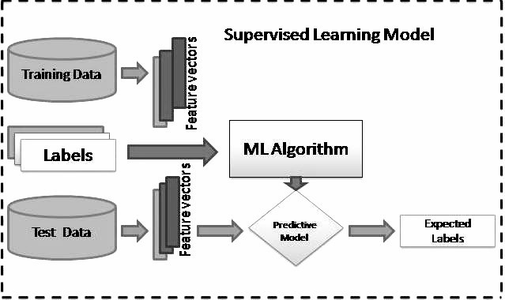

Fig. 2.1 Supervised Machine Learning Model C.D. Manning, P. Raghavan and H. Schuetze (2008). Introduction to Information Retrieval. Cambridge University Press, pp. 234-265. [https://nlp.stanford.edu/IR-book/html/htmledition/naivebayes-text-classification-1.html](https://nlp.stanford.edu/IR-book/html/htmledition/naive-bayes-text-classification-1.html)

#### 2.1.2.1 The Multinomial Naive Bayes (MNB) Classifier

This is a known choice for text classification in machine learning. This classifier along with the naive Bayes variant is often utilized in text classification tasks that involve discrete features like word counts. Essentially, it's an algorithm that predicts the class of a document by analysing the presence of words, within it. The core principle of Naive Bayes is the assumption of conditional independence, meaning that the presence of one feature does not affect the presence of another, given the class. (Manning et al., 2008) The multinomial distribution normally requires integer feature counts. However, in practice, fractional counts such as TF-IDF may also work.

The Multinomial Naive Bayes method determines the likelihood of a document d belonging to class c based on the likelihood of the words, in the document appearing in that class. The likelihood is determined by applying Bayes Theorem as outlined by (Manning et al., 2008):

In this scenario, P(c|d) represents the chance of class c based on document d while P(d|c) shows how likely.

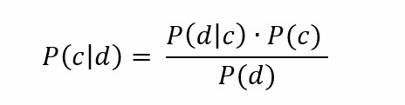

Where $P\left(c | d\right)$ is the posterior probability of class c given the document d, $P\left(d | c\right)$ is the likelihood of the document d given class c, $P(c)$ is the prior probability of class c and $P\left(c\right)$ is the prior probability of the document d, which is constant across classes.

In the Multinomial Naive Bayes model, the likelihood $P\left(d | c\right)$ is expressed as the product of probabilities of individual words $w_{i}$ ​given the class c:



Where n is the number of unique words in the vocabulary, $P\left(w_{i} | c\right)$ is the probability of word $w_{1}$ ​ occurring in class c, and $f(w_{i}|d)$ is the frequency of word $w_{1}$ ​ in document d.

To estimate $P\left(w_{i} | c\right)$, the Multinomial Naive Bayes model uses:

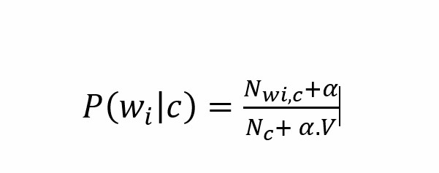

Where $N_{wi,c}$ ​ is the number of times word $w_{i}$ appears in documents of class c., $N_{c}$ ​ is the total number of word occurrences in class c, V is the total number of unique words in the vocabulary, and α (alpha) is a smoothing parameter, often set to 1 (Laplace smoothing), to handle zero probabilities.

To calculate Prior probability, $P\left(c\right)= \frac{N_{c}}{N}$ Where $N_{c}$ ​ is the number of documents in class c and N is the total number of documents across all classes.

The classification of a new document is done by computing P(c∣d) for each class c and selecting the class with the highest posterior probability. Since P(d) is constant, it can be ignored in the calculation, simplifying the expression to:

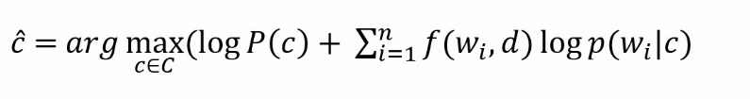

Where $\hat{c}$ is the predicted class.

By assuming independence, the model can efficiently manage vocabularies without consuming excessive computational resources making it ideal, for applications requiring real time processing.

This idea was highlighted by Kaur and colleagues in their 2021 study.

The smoothing priors α ≥ 0 accounts for features and words do not present in the learning samples and prevents zero probabilities in further computations. When α = 1 it referred to as Laplace smoothing whereas when α < 1 its known as Lidstone smoothing (Manning et al., 2008).

The Multinomial Naive Bayes classifier excels, in accuracy and precision compared to the Bernoulli Naive Bayes classifier especially as the data volume increases. (Kaur et al., 2021) introduces Multinomial Naive Bayes as a model for sentiment analysis emphasizing its efficiency in tasks while also suggesting the requirement, for advanced models to grasp intricate text nuances.

#### 2.1.2.2 Random Forest Classifier

This is a technique in machine learning that is commonly employed for both classification and regression purposes. It is based on constructing a multitude of decision trees during training and outputting the mode of the classes (classification) or mean prediction (regression) of the individual trees. (Abdulkareem & Abdulazeez, 2021). It grows multiple decision trees, each tree is trained on a bootstrapped sample of the training data, and at each node the algorithm only searches across a random subset of the variables to determine a split. When categorizing an input vector, in a forest model the vector is presented to every tree within the forest.

The classification is decided based on the most common outcome, through a voting process. (Gislason et al., 2004). RF has demonstrated effectiveness, to bagging and boosting techniques (Bernard et al., 2013). Has been utilized in different domains like remote sensing and land cover classification (Kulkarni & Lowe, 2016). The Random Forest algorithm possesses characteristics, such, as Variable Importance Measure, out of bag error and Proximities which contribute to its widespread adoption as a classification method.

The mathematical principle of randomness employed in feature selection, where a random subset of features is chosen at each node to determine the best split, enhancing the model's ability to generalize by introducing diversity among the trees. Random Forest's operation involves several mathematical key steps. At first when working with a dataset containing n samples and m features, we start by drawing 𝑁 bootstrap samples. For each of these bootstrap samples we construct a decision tree. At every node of the tree the optimal split is determined from a subset of K features (where 𝑘<<𝑚). The criteria used for finding the split can be either Gini impurity or Information Gain which're mathematical metrics that assess how consistent the target variable is, within different subsets.

**Gini Impurity** is calculated as:

where $p_{i}$ is the probability 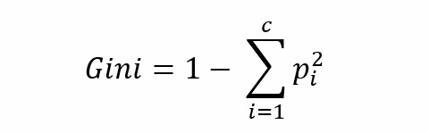of a particular class at a node and c is the number of classes.

**Information Gain**, used in entropy-based methods, is defined as:

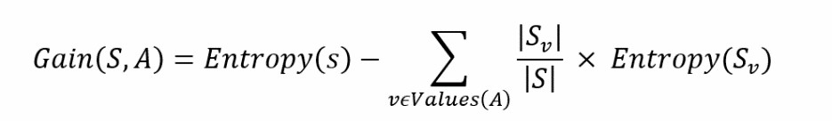

where Entropy(S) is the entropy of the dataset S, and Sv​ is the subset for a particular feature value.

In a Random Forest model every tree offers a prediction, for an input. The overall classification result is decided by combining these predictions using either a voting system for classification purposes or an averaging method, for regression tasks.

The mathematical model of the Random Forest can be represented as:

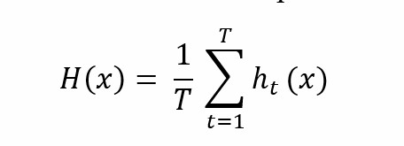

where H(x) is the final prediction, T is the total number of trees, and ht(x) is the prediction of the t-th tree.

Random Forest stands out in mathematics for its ability to combat overfitting effectively. This algorithm finds applications, such, as in classification, intrusion detection, content filtering, sentiment analysis and even image processing (Abdulkareem & Abdulazeez, 2021). A study by (Paul et al., 2018) revealed that adding trees or reducing features further does not necessarily enhance classification accuracy. Recent research has delved into enhancing Random Forests precision by exploring split measures and combination functions alongside improving performance through pruning and estimating optimal forest subsets (Bernard et al., 2013).

### **2.1.3 Natural Language Processing (NLP)**

Natural Language Processing (NLP) is a branch of intelligence that focuses on how computers interact with languages. NLP involves analysing amounts of text data to help computers understand, interpret, and produce human language for various purposes. Its main goal is to empower computers to perform language related tasks such, as understanding text providing responses extracting information and facilitating communication between languages. To achieve these objectives NLP integrates principles from fields like statistics, computational science, machine learning and linguistics. Users can extract insights from text datasets, analyse content and access personalized news tailored to their preferences. The field of NLP has made progress in years thanks to advancements in advanced machine learning techniques like deep learning and the availability of extensive datasets. These developments have enabled computers to carry out tasks that traditionally required intelligence. The growth of NLP has been driven by the increasing volume of content and the growing demand for intelligent information extraction, from these sources.

In the field of natural language processing (NLP) computational linguistics, intelligence and computer science converge. "Natural language" refers to the language humans use in their conversations (Bird et al,. 2009). NLP enables an understanding of data, through human language processing. In the field of natural language processing (NLP) we often use structure and different parts of speech, like nouns, verbs, and adjectives. NLP must cope with anaphora and ambiguity in addition to part-of-speech and grammatical structure. To deal with this, knowledge representations are needed, such as lexicons of words and their meanings, grammar rules, and grammatical features, as well as thesauri of synonyms and abbreviations.

Key aspects of natural language processing (NLP) cover categorizing text recognizing named entities analysing sentiments translating languages with machines and understanding spoken words (Dande & Pund, 2023). The remarkable advancements, in NLP have opened doors to a wave of applications. These technologies can interpret, create content, and engage in conversations making an impact in fields like virtual assistants (e.g., Alexa, Siri) chatbots, sentiment analysis and language translation (Yadav et al., 2024). In essence NLP is revolutionizing interactions between humans and computers while enabling the extraction of information from textual data sources (Chopra et al., 2013). NLP finds uses in healthcare, finance, education, and customer service sectors (Yadav et al., 2024). Despite its advancements NLP encounters challenges, like grasping context intricacies and cultural subtleties (Yadav et al., 2024).

#### 2.1.3.1 Sentiment Analysis Techniques:

Sentiment analysis is an area, within Natural Language Processing (NLP) that focuses on automatically identifying emotions in text often categorizing them as positive, negative, or neutral. It involves a mix of linguistics, computer science, NLP, and machine learning to extract details from text. Sentiment analysis can be useful for tasks like text classification and summarization by utilizing methods such as machine learning algorithms and rule-based systems to gauge sentiment. Text is typically categorized as positive, neutral, or negative with a score reflecting the intensity of the sentiment. Applications of sentiment analysis include tracking media trends monitoring customer feedback and analysing comments. Machine learning algorithms are crucial in classifying text content based on emotions and opinions using NLP techniques. In business settings sentiment analysis helps companies identify customer perceptions about their products or services to make decisions. However, challenges exist in sentiment analysis such, as detecting sarcasm accurately interpreting sentiments from texts and determining the polarity of sentiments. Despite facing these obstacles, it still serves as an asset for companies to grasp customer feedback and reach thought out conclusions (Nalini et al., 2022). This area is constantly developing, integrating advancements in language processing and text analysis (Wankhade et al., 2022).

The analysis of sentiments, in drug reviews has become significant in the healthcare field offering perspectives on experiences and the efficacy of medications. Several research studies have delved into this area using techniques in natural language processing. (Na & Kyaing, 2015) devised an algorithm for sentiment analysis at the clause level incorporating knowledge to enhance accuracy. (Yadav & Vishwakarma, 2020) introduced a framework for text representation with weights achieving accuracy rates and F1 scores. (Hiremath & Patil, 2020) concentrated on creating a system to support decisions using sentiment analysis based on aspects and machine learning approaches. These research works showcase the effectiveness of methods in evaluating drug reviews holding promise for enhancing healthcare decision making improving patient care and providing insights, for both drug manufacturers and healthcare professionals (Yadav & Vishwakarma, 2020).

Sentiment Analysis techniques includes the following: Sentiment Analysis using Lexical Analysis, Sentiment Analysis using Machine Learning and Sentiment Analysis using Deep Learning

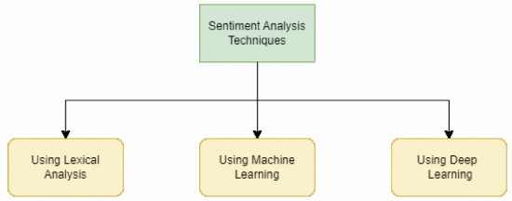

Sentiment Analysis Technique [Source: Sindhu, S., Kumar, S. and Noliya, A.

(2023c) 'A Review on Sentiment Analysis using Machine Learning,' <https://doi.org/10.1109/icidca56705.2023.10099665>.]

### **2.1.4 Patient Satisfaction with medication:**

Patient satisfaction is becoming increasingly popular as an indicator of the quality of health care services, including pharmaceutical services. Satisfaction can be conceptualized as a performance evaluation, disconfirmation of expectations, an affect-based assessment, or an equity-based assessment. A satisfaction measure should have a theoretical base on which the measure's validity can be assessed. Patient satisfaction with medication is an important aspect of healthcare that influences treatment adherence and outcomes. Studies have shown that satisfaction is influenced by factors such as effectiveness, side effects, convenience, and cost (Alam et al., 2018). Demographic and social factors, including age, residence area, and health status, can affect various aspects of medication satisfaction (Geitona et al., 2008). Research in this field has primarily focused on developed economies, with a need for more studies in emerging markets (Alam et al., 2018). Understanding patient satisfaction with medication is crucial for improving healthcare quality and patient outcomes.

Patient satisfaction with medication: this is gaining traction as a measure of healthcare quality, including pharmaceutical services. Satisfaction can be viewed as an evaluation of performance meeting or exceeding expectations, an assessment, or a fairness evaluation. It's essential for a satisfaction metric to have a foundation to assess its validity. Patient satisfaction with medication plays a role in healthcare by impacting treatment adherence and results. Research indicates that satisfaction is influenced by factors like effectiveness, side effects, convenience and cost (Shikiar & Rentz, 2004). Demographic and social elements such as age, location of residence and health status can impact aspects of medication satisfaction (Geitona et al., 2008). While existing studies largely focus on developed nations there's a call for research in emerging markets (Alam et al., 2018). Understanding satisfaction with medication is crucial, for enhancing healthcare quality and patient wellbeing.

## **2.2 REVIEW OF RELATED WORKS:**

In a research project, by (Raja et al., 2022) they delved into comparing machine learning models like Logistic Regression, XGBoost and Naïve Bayes to determine how well they can distinguish between positive and negative drug reviews. The study revealed that XGBoost achieved an accuracy rate of 79.7%. Their primary aim was to pinpoint the model for categorizing reviews as positive or negative aiding healthcare professionals in gauging public opinions on specific medications. However, there are obstacles and constraints to consider. The intricacies of terminology pose challenges for sentiment analysis as conventional approaches may struggle to capture the subtleties of language. Imbalances in data distribution, where sentiments are unevenly spread can result in inaccuracies such as positives or negatives impacting the dependability of the model. Extensive preprocessing is essential to address stop words and clean up the data, which adds a layer of complexity to the analysis. Furthermore, model performance can vary based on the dataset used; while XGBoost excelled models like Logistic Regression also show potential. Concerns arise regarding generalization since models trained on datasets may not perform adequately with data. Lastly advanced models like XGBoost require resources potentially limiting scalability and real time implementation. These challenges underscore the necessity for enhanced methods and models to effectively manage the complexities of sentiment analysis in drug reviews.

(Muhammad et al., 2019) presented a study that compares the effectiveness of the Multinomial Naive Bayes (MNB) algorithm and Logistic Regression (LR) for intent classification in chatbots, aiming to determine which method more accurately classifies user input into predefined categories such as "greet," "report," and "info." The research involves analysing the dataset, with TF IDF (Term Frequency Inverse Document Frequency) to convert text information into attributes followed by training Naive Bayes and Logistic Regression models. The outcomes show that Logistic Regression surpasses Naive Bayes achieving accuracy of 72.7% compared to 63.6% along with precision and recall. Nevertheless, the study faces obstacles and restrictions such as utilizing an unbalanced dataset that might not generalize well to larger and more varied datasets, as well as the risk of overfitting where models may excel on the training data but poorly on unseen data. Despite these constraints the study concludes that Logistic Regression is more suitable for classification. However, it advises caution when interpreting the results.

(Helae et al., 2022) discussed how data analytics can be applied in the field of pharmacology specifically focusing on analysing the sentiments expressed in reviews of drugs. The main goals of their research include assessing satisfaction with medications, predicting health conditions based on feedback, and pinpointing the most effective drugs for specific ailments. They used a dataset from the UCI Machine Learning Repository that includes reviews and ratings. Their approach involved preparing the data by extracting features using methods like TF IDF and Bag of Words and employing machine learning techniques such as Random Forest (RF) Support Vector Machine (SVM) and deep learning models like Long Short Term Memory (LSTM). The results show that sentiment analysis with RF and SVM can effectively categorize patient reviews to gauge satisfaction levels. LSTM was utilized to forecast drug ratings and identify performing medications for conditions. However, they encountered challenges dealing with large amounts of data and ensuring precise feature extraction from text-based information. They noted limitations related to training models due to data nature underscoring the importance of refining data processing methods and enhancing model accuracy.

(Sivaiah et al., 2024) conducted a study focusing on a Drug Recommendation System that utilizes sentiment analysis of reviews, through Machine Learning. Their goal was to create a drug recommendation system based on understanding feedback. The research utilizes machine learning methods to examine how patients feel using techniques, like Bag of Words Term Frequency Inverse Document Frequency (TF IDF) and Manual Feature Analysis. They apply classification algorithms such as a Linear SVC classifier to predict patient sentiments. The results show that combining the Linear SVC classifier with TF IDF vectorization achieved higher accuracy compared to models tested. The conclusions were drawn from evaluating systems using metrics such as precision, recall, F1 score, accuracy, and AUC score. The key findings highlight the potential of machine learning in improving drug prescription accuracy by customizing recommendations for patient requirements leading to better healthcare outcomes. While the results are promising the research paper acknowledges challenges like integrating algorithms and requiring datasets for effective model training.

Addressing issues related to data privacy and security is crucial along with considering all aspects, in automated healthcare decision making processes.

(Garg, 2024) created a Drug Recommendation System that relies on analyzing the sentiments expressed in drug reviews through Machine Learning. The research focuses on crafting a system for suggesting drugs that can ease the workload of healthcare practitioners by evaluating feedback. The study uses machine learning methods and vectorization techniques, like Bag of Words (BoW), TF IDF, and Word2Vec to convert text reviews into formats for categorization. The research utilizes the Drug Review Dataset from the UCI Machine Learning repository, which contains more than 215,000 cases. The data is prepared by eliminating entries, duplicates, and unnecessary details to guarantee an input for the models. The information is divided into two parts, for training and testing and the Synthetic Minority Over Sampling Technique (SMOTE) is used to tackle imbalances in classes. Various types of classifiers, like Linear Support Vector Classifier (LinearSVC) Random Forest, Naive Bayes and more were examined using metrics such as precision, recall, F1 score, accuracy, and AUC. The results show that the linear SVC model, with TF IDF vectorization performed best in terms of accuracy. Although the system shows results the authors recognize constraints related to the medical language used in reviews, which makes sentiment analysis challenging and calls for advanced linguistic models.

(Bagwan et al., 2021) conducted a study on creating a system for gathering feedback that utilizes sentiment analysis to gain insights into patient experiences with hospital services. They investigated machine learning algorithms like Decision Tree, Logistic Regression, K Nearest Neighbors, Multinomial Naive Bayes Classifier and Random Forest to compare their performance based on accuracy and F score. To improve accuracy the researchers employed an Ensemble Learning method that combines predictions from base classifiers. Feedback was collected in languages such as Hindi, Marathi and English before being translated into English using Google Translator for analysis. The results show that the Ensemble Classifier surpassed models by achieving accuracy in sentiment classification. However, the study highlighted challenges in dealing with text and accurately translating nuanced feedback. It also recognized the limitations of relying on input as it may not capture all nuances of patient sentiment, like sarcasm or context-specific details.

(Iqbal, Umar & Almohsen 2023) conducted a study, on Drug Sentiment Analysis Using Machine Learning Classifiers. Their research focused on utilizing machine learning methods to assess the efficacy of drugs based on user feedback. The main goal of the study was to offer insights that could assist consumers in making informed decisions regarding drug usage. The initial steps involved breaking down the text into components through tokenization and lemmatization to simplify its complexity. The study evaluated four machine learning algorithms for classification: Naive Bayes Classifier, Random Forest, Support Vector Classifier (SVC) and Multilayer Perceptron (MLP). In terms of classification, Linear SVC was utilized. Results indicated that the Random Forest algorithm performed best for classification while Linear SVC excelled in scenarios particularly in Class 2. However, the study encountered challenges such as classifying data due to the intricate nature of natural language processing and limited specialized terms in the dataset. Furthermore, it underscored the complexities associated with multi classification compared to classification due to increased intricacies in distinguishing between categories of drug effectiveness. The study concluded that although the Random Forest algorithm shows potential in sentiment analysis further enhancements and additional features may be required to improve performance in classification within drug sentiment analysis applications.

## **2.3 RESEARCH GAP:**

This research project aims to deepen our understanding of supervised machine learning by focusing on improving performance and comparing two models. Specifically, it investigates the use of TF IDF for extracting features and SMOTE for balancing classes to address overfitting concerns. While previous studies have extensively examined machine learning models there is a need to explore the trade-offs between model complexity and scalability regarding class balancing in handling datasets. This study endeavours to fill this gap by offering insights into managing these challenges while developing scalable machine learning solutions.

# **CHAPTER THREE**

# **METHOD**

This chapter three talks about the tools and technique used to develop a sentiment analytical system to enhance patient satisfaction on medications with user interface.

## **3.1 TOOLS**

This section discusses the materials utilized in this research project. The resources employed include Python 3.7 Google Colab Pro, Visual Studio Code (VS Code), Spacy, Pandas, Numpy, Matplotlib, seaborn, sklearn, python flask etc.

### **3.1.2 PYTHON**

Python stands out as a utilized programming language known for its applications in creating machine learning models, developing websites, software automation tasks and data analysis. As programming language, Python is suitable for a range of applications and isn't limited to any specific problem domain (Python.org, 2022). Its flexibility and user-friendly nature have significantly contributed to its acceptance, establishing it as one of the preferred programming languages. Notably, Python was ranked as the most popular programming language among developers in 2021 according to a survey by RedMonk.

WHAT IS PYTHON USED FOR?

In this project, Python is employed for creating machine learning systems (intelligence system), pre-processing, analysing and visualizing data. Python has become increasingly popular among programmers, such as accountants and scientists for everyday tasks such as organizing finances. As Charles R. Severance mentions in his book "Python for Everybody" writing code is a fulfilling endeavour. People write code for reasons whether it’s to earn a living, tackle data analysis problems, have fun or assist others in problem solving tasks. Python serves purposes such as data analysis and machine learning, web development, automation, scripting, software testing and prototyping.

The specific version of Python utilized in this project is Python 3.11.9.

### **3.1.3** **Visual Studio Code (VS Code)**

Visual Studio Code, also known as VS Code, is a code editor created by Microsoft that offers a range of functionalities for developers working on projects in programming languages. It combines the simplicity of a text editor with features typically found in development environments (IDEs) such as IntelliSense for autocomplete suggestions, syntax highlighting, and debugging capabilities. One of the standout features of VS Code is its collection of extensions that allow users to tailor the editor to their requirements. Whether it’s adding support for programming languages like Python or JavaScript or integrating tools like Docker and Git, developers can customize their coding environment to enhance productivity. The built in Git integration streamlines version control tasks within the editor itself thereby facilitating tasks like commits, branch management and resolving merge conflicts effortlessly. Moreover, Visual Studio Code is compatible across operating systems including Windows, macOS and Linux – ensuring a good user experience regardless of platform. Features such as Live Share further elevates its utility by enabling real time collaboration among individuals and teams during software development projects.

The version being utilized for this project is Visual Studio Code Version 1.92.1 (user setup).

### **3.1.4 Pandas**

This is a utilized Python library that is very important in designing models and developing algorithms, especially within the realms of data science and machine learning. It offers data structures such as Series and Data Frame facilitating manipulation and analysis of data. Through Pandas developers can easily manage tasks like data cleaning, transformation, and aggregation to streamline preparation for modelling purposes. Pandas excels in handling datasets by providing functions for filtering, merging and reshaping data. Steps during the data preprocessing stage. Moreover, it seamlessly integrates with libraries like NumPy, Matplotlib and Scikit learn proving to be a resource, for creating robust algorithms and data centric models using Python.

The current version being utilized is Pandas Version 2.2.2., which was installed through the command 'pip install Pandas in the VS Code terminal.

### **3.1.5 Numpy**

NumPy is a Python library that is widely utilized for designing models and developing algorithms for scientific computation and data analysis. It offers support for handling multi-dimensional arrays and matrices along with an extensive array of mathematical functions to manipulate these arrays. This functionality is crucial for managing data and facilitating speedy and memory efficient calculations. Its features related to linear algebra, random number generation and Fourier transforms are frequently employed in algorithm creation across fields such as machine learning, physics, and engineering. Additionally, NumPy serves as the cornerstone for libraries like Pandas and Scikit Learn that seamlessly integrate to support various tasks in Python ranging from data preprocessing to model enhancement.

The specific version of NumPy being used is Version 1.26.4 which was installed by executing 'pip install numpy', within the VS Code terminal.

### **3.1.6 Spacy**

Spacy stands out as a Python library designed for natural language processing (NLP) tasks, widely employed in algorithm creation and data preparation. This tool provides a variety of features for handling and examining text datasets, such as tokenization, identifying parts of speech recognizing named entities parsing dependencies and more. These functions are crucial for developing NLP algorithms and models that necessitate an understanding of language structure and semantics. One key advantage of Spacy lies in its speed and efficiency enabling processing of large text corpora making it well suited to real time applications. Moreover, Spacy offers pretrained language models that can be fine-tuned to meet requirements empowering developers to utilize existing knowledge without starting from scratch. The library also aids in enhancing its functionality for creating NLP models. In summary Spacy proves to be a tool for preprocessing data and constructing sophisticated algorithms within the realm of natural language processing.

The specific version utilized is Version 3.7.5 of Spacy which was installed through the 'pip install spacy' command, on the VS Code terminal.

### **3.1.7 Matplotlib:**

Matplotlib is an essential Python library for developing algorithms for data visualization. It offers a range of tools for creating animated and interactive plots to help developers analyse data visually. This visual analysis is crucial for understanding data patterns and trends which is important for algorithm development and evaluation. Developers can use Matplotlib to create types of plots like line graphs, bar charts, histograms, scatter plots and more with customization options. It also integrates seamlessly with Python libraries such as NumPy, Pandas and SciPy simplifying the visualization of data from these sources. By providing a representation of data Matplotlib assists developers in debugging optimizing and explaining their performance. Making it an invaluable tool in the Python ecosystem for algorithm development.

The version of Matplotlib being utilized is Version 3.9.0; it was installed via 'pip install matplotlib' in the VS Code terminal.

### **3.1.8 Scikit-learn (sklearn):**

Scikit Learn is a robust Python library that is extensively utilized for developing algorithms and working on machine learning tasks. It offers a set of resources for creating, training, and assessing machine learning models making it a favoured choice for newcomers as well as seasoned professionals. The library supports machine learning techniques such as metrics, classification, regression, clustering and dimensionality reduction all conveniently accessible through a consistent interface.

An important feature of Scikit Learn is its user nature enabling developers to swiftly implement and experiment with algorithms. It also provides tools for data preprocessing including feature scaling, encoding and dataset splitting – steps in preparing data for model training. Moreover, Scikit learn seamlessly integrates with Python libraries like NumPy and Pandas to facilitate data handling making it a flexible asset in the machine learning process. Whether designing models or deploying them in real world scenarios Scikit Learn equips users with the resources to create robust and effective machine learning solutions, in Python.

The specific version of Scikit learn being used is Version 1.5.0 which was installed by executing 'pip install sklearn' in the VS Code terminal.

### **3.1.9 Seaborn:**

Seaborn is a Python visualization tool that enhances data visualization in the realms of algorithm development and machine learning. It offers a user interface for creating appealing statistical graphics simplifying data exploration for developers. Seaborn stands out for its ability to generate visualizations like heatmaps, categorical plots and pair plots with coding effort. These visual representations play a role in understanding relationships between variables and uncovering patterns in data for machine learning model development decisions. Seaborn seamlessly integrates with Pandas DataFrames enabling plotting from commonly used datasets in machine learning workflows.

The version being used is Version 0.13.2 installed through 'pip install seaborn', on the VS Code terminal.

### **3.1.10 Textblob:**

TextBlob is a Python library that aims to simplify the processing and analysis of text data making it an asset in developing algorithms and machine learning models. It offers an intuitive interface for carrying out natural language processing tasks like identifying parts of speech, extracting noun phrases, analysing sentiments, and translating text. This user-friendly approach enables developers to seamlessly incorporate NLP functionalities into their projects without needing knowledge of language processing. Additionally, TextBlob streamlines text preprocessing tasks such as tokenization and lemmatization which are essential for preparing data for advanced NLP applications. Its seamless integration with libraries such as Pandas for data manipulation and Matplotlib for visualization further enhances its utility in analysing and presenting data.

The specific version of TextBlob mentioned is Version 0.18.0.post0, which was installed by executing 'pip install textblob', in the VS Code terminal.

### **3.1.11 Google Colab:**

Google Colab is designed for data scientists, machine learning practitioners, and Python developers. Due to the size of the research dataset, there was a need to increase its RAM and extend the session duration which led to the subscription of Google Colab Pro and Google Colab Pro+ subsequently. Google Colab is a powerful tool for developing and training machine learning models. Additionally, it enables teamwork by allowing users to share notes and integrate with Google Drive, this makes doing group projects easier and possible.

## **3.2 METHOD JUSTIFICATION**

To create a reliable data model for this project, it was essential to choose a methodology that aligns with the project’s goals. Extensive research was conducted before starting this study to explore methodologies and determine the appropriate approach. One of the methods investigated was the Team Data Science Process (TDSP), introduced by Microsoft in 2016. The TDSP framework consists of five phases: Business Understanding, Data Acquisition and Understanding Modeling, Deployment and Acceptance. This methodology offers an approach to managing data science projects. Another method considered was SEMMA developed by SAS, which stands for Sample, Explore, Modify, Model and Assess. SEMMA is designed to address a range of business challenges such as fraud detection, database marketing, customer loyalty programs, bankruptcy forecasting, market segmentation strategies, customer retention strategies, risk analysis techniques, affinity analysis approaches and portfolio analysis methods. The third methodology reviewed was OSEMN. Obtain, Scrub, Explore, Model and Interpret. Known for its simplicity and effectiveness in handling data science workflows. Additionally, Knowledge Discovery in Databases (KDD) was also considered. The process known as KDD involves stages, including data selection, data cleaning, data integration, data transformation, data mining, pattern evaluation and knowledge presentation. Upon reviewing methodologies, I found the CRISP DM (Cross Industry Standard Process for Data Mining) approach to be particularly compelling. CRISP DM offers a comprehensive framework for managing data mining/machine learning projects. It comprises of six phases: Business Understanding, Data Understanding, Data Preparation, Modelling, Evaluation and Deployment. The iterative nature of CRISP DM supports refinement and enhancement of models.

I ultimately opted for the CRISP DM methodology due to its adaptability and thoroughness. This methodology allows for in depth exploration of both the problem at hand and the available data. It facilitates model creation and evaluation while ensuring deployment and acceptance of the solution. In this project context CRISP DM guided the development of a sentiment analysis system to improve satisfaction with medications through a customized user interface tailored to their needs. This approach provided a structure for meeting project requirements. Delivering a top-notch solution.

### **3.2.1 Methodology adopted for the project.**

CRISP DM, known as the Cross Industry Process for Data Mining provides a framework for organizing and carrying out projects in data mining, machine learning and data science. It is a recognized and an adaptable methodology valued for its effectiveness in solving business challenges. The CRISP DM approach emphasizes flexibility, allowing tasks to be completed in order and often requiring refinement through repetition. While it may not cover every scenario in the data mining process its main goal is to improve project efficiency, reliability, cost effectiveness and adaptability. The methodology consists of six stages: Business Understanding, Data Understanding, Data Preparation, Modelling, Evaluation, and Deployment. Each stage typically loops back to the previous one, in a fashion to allow for continuous review and adjustment as necessary. This iterative process enables revisiting and enhancing stages to ensure results.

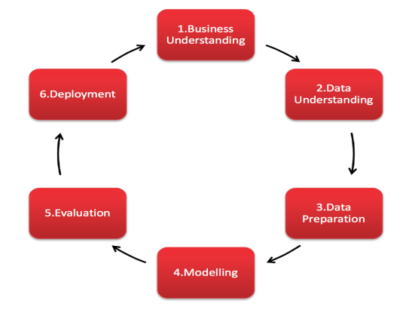

*Figure 3.1: CRISP-DM Methodology (Source:* [*https://www.sv-europe.com/crisp-dm-methodology/*](https://www.sv-europe.com/crisp-dm-methodology/)*)*

## **3.3 TECHNIQUE:**

In this section, CRISP DM methodology was applied to this research, which explains approach and outlines how the project was carried out by following the six stages of CRISP DM. Below are the actions taken to ensure that this project was comprehensively completed.

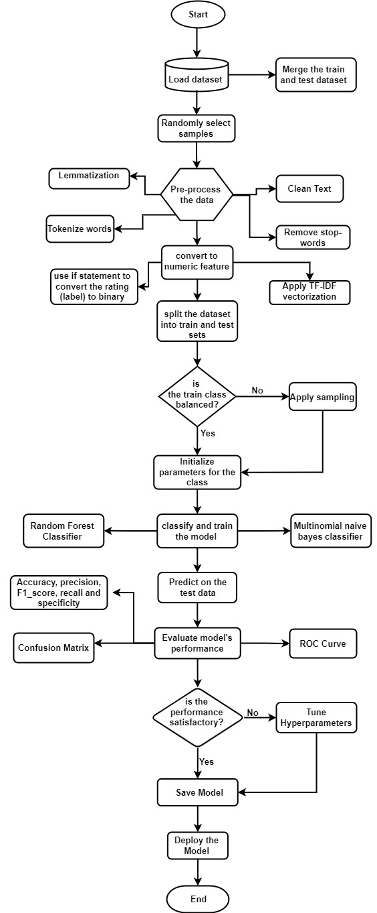

*Figure 3.2 Flowchart algorithm of the Sentiment Analytical System*

### **3.3.1 Stage 1: Business Understanding (Identify Your Business Goals)**

The first and crucial stage in this application of sentiment analytical system to enhance patient satisfaction with drugs using machine learning models project is Project’s Understanding. At this stage, extensive research was carried out to understand the primary aim which is to enhance patient satisfaction with drugs which was gotten because of the gap in the existing systems. This aim is intended to be achieved by gaining insights into patient experiences with various drugs and identifying areas for improvement. Additionally, the researcher understood and created the project’s specification, including its economic impact, legal, social, ethical, and professional issues which are very essential as it lays a strong foundation for the successful implementation of this system. The following specific objectives were established as stated in the project objective in chapter 1 (1.9).

### **3.3.2 Stage 2: Data Understanding**

This is the second stage of the CRISP-DM Methodology. This is the point where the data for this project was fully understood. Having the primary aim of enhancing patient satisfaction on drugs, the researcher discovered that a data with patients reviews on drugs and ratings will be required in other to successfully deliver this project. Data was sourced and downloaded from an open-source Kaggle which is a community platform that provides a collaborative environment that hosts datasets, and notebooks. The data has a Creative Commons Attribution 4.0 International (CC BY 4.0) license. (<https://archive.ics.uci.edu/dataset/462/drug+review+dataset+drugs+com> ). See Appendix 1 for a screenshot of the license. Which allows for the sharing and adaptation of the datasets for any purpose, provided that the appropriate credit is given (Gräßer et al., 2018).

#### 3.3.2.1 Data Description:

This dataset named UCI ML Drug Review dataset curated from Kaggle (<https://www.kaggle.com/datasets/jessicali9530/kuc-hackathon-winter-2018/data>) is a patient’s review on drugs dataset. The dataset has 7 features which includes:

UniqueID, drugName, condition, review, rating, date, usefulCount.

See Appendix 2 for a screenshot of the dataset showing its features and some records. (Gräßer et al., 2018).

### **3.3.2.2 Dataset Reading:**

### The dataset which was downloaded from Kaggle was uploaded to Google drive for easy accessibility through Google colab. These CSV datasets with names drugsComTrain_raw and drugsComTest_raw were loaded (read) using Pandas and including the exact storage path of these datasets on the Google drive directory. The Google drive was first connected and mounted on the Goggle colab by importing drive from Google colab, after which these datasets were read individually using this syntax. Go to Appendix 3.

### **3.3.2.3 Exploratory Data Analysis:** The data table was viewed using the head function. The shape function was also applied to the column and row size of the dataset. The describe function is a summary statistic presenting the count, mean, standard deviation etc. The function info gives a detail explanation on column, row, type etc. Graphs and charts were plotted to view distribution and check for imbalance data distribution. See Appendix 4-6.

### **3.3.3 Stage 3: Data Preparation**

This is the third stage of the CRISP-DM Methodology where the data was loaded and pre-processed to build the machine learning models. The data preparation involves the following steps:

#### 3.3.3.1 Dataset Merge**:** The two sets of the data were merged to undergo cleaning and preprocessing using pd.concat, a function, within the Pandas library. The outcome was saved in a variable that was then utilized for data preparation. Refer to Appendix 7 for **details.**

#### 3.3.3.2 Dataset Sampling: In this part of data preparation, the researcher randomly choose samples to train the model which helps in decreasing the datasets processing time. The syntax below was used to perform this process:

#### 3.3.3.3 Dataset preprocessing: The Spacy model for pre-processing was loaded with this syntax: nlp = spacy.load('en_core_web_sm'), after which the dataset was cleaned and pre-processed by undergoing the following processes:

1) Checking for null values and dropping them.

2) Removal of punctuations.

3) Lowering of text.

4) Applying of regular expressions (regex) to remove non-letters.

5) Replacing of n’ t with not.

6) Tokenization.

7) Lemmatization.

8) Removal of stopwords.

Most of these processes were written as a single function and applied to the dataset.

Go to Appendix 8.

#### 3.3.3.4 Feature Engineering: Feature engineering plays a role, in machine learning and natural language processing (NLP) by creating meaningful features from raw data. TF IDF (Term Frequency Inverse Document Frequency) serves as a as a mathematical measure for evaluating the importance of words in documents. It provides a representation of text data that evaluates the significance of words within a document compared to a set of documents. This method captures the importance of words in documents while accounting for their frequency across the entire corpus. To achieve this the TF IDF vectorizer is employed to transform the variables (features). Refer to Appendix 9 for insights into how TF IDF vectorization was carried out on the cleaned review.

#### 3.3.3.5 Data Splitting and Oversampling: As part of preparing the data for modelling, the data was split into train and test set using 80/20 practice which ensures that the model can be evaluated on unseen data. This is so that the train sets will be used to train (fit) the model while the test set will be used to test and make predictions. The data was split using the Scikit learn model selection library, passing the test size and random state.

Furthermore, the data was checked for imbalanced classes which is a situation where one class in a classification problem has significantly fewer examples than another class. This is because an imbalanced class can lead to biased model performance and incorrect predictions, as the model may prioritize the majority class and perform poorly on the minority class. To handle the class imbalance, SMOTE was used.

SMOTE which means Synthetic Minority Over-sampling Technique is a method in the imblearn library. It is designed to address issues with class imbalances in dataset classification situations. The main purpose of SMOTE is to generate instances for the minority class, thereby achieving a balanced dataset by boosting the representation of the underrepresented class. Go to Appendix 10 for details.

### **3.3.4 Stage 4: Model Training**

This is the fourth stage of the CRISP-DM Methodology which is very vital in machine learning and focuses on leveraging datasets to train algorithms in identifying patterns and correlations within the data. The goal is to create a model that will effectively predict or make classifications on new, unseen data. This procedure comprises steps.

#### 3.3.4.1 Selecting the Model:

In this initial sub-stage, appropriate machine learning algorithms are chosen based on the nature of the sentiment analysis task. Common models for sentiment analysis include Multinomial Naïve Bayes, Random Forest Classifier, Logistic Regression, and Support Vector Machines (SVM). For this system, a model capable of handling textual data and capturing nuances in sentiment is selected. The problem of this research work is classification of textual into positive and negative sentiments. The project will adopt the following ML algorithms.

**Multinomial Naïve Bayes:**

The multinomial Naive Bayes classifier is a known type of Naïve Bayes model commonly used in text classification, with discrete features like word frequencies for classifying text. It is a probabilistic method employed to forecast the class of a document by analysing word occurrences. Multinomial Naive Bayes was selected due to its speed, performance, and efficiency particularly when handling large datasets.

The Multinomial Naïve Bayes classifier was built from scratch by inheriting from BaseEstimator and ClassifierMixin, two classes from the sklearn library which is used to define custom estimators.

Laplace Smoothing: This is a Multinomial Naïve Bayes Classifier smoothing parameter which helps to handle zero probabilities by adding a small value (alpha) to the word count. Its default value is 1.0.

The following are the explanations of the Multinomial Naïve Bayes algorithm after data preparation:

Step 1: initialize the Multinomial Naive Bayes class with a smoothing parameter alpha, which helps with Laplace smoothing.

Step 2: Train the classifier by calculating the class prior probability and the likelihood of each word in a document for each class (conditional word probabilities).

Step 3: Predict the input data by calculating the logarithm of the probability for each class group and selecting the class with the log probability for each document.

Step 4: Return the class with the highest log probability.

Step 5: Return the class probabilities (normalized) for each document, which can be useful for the evaluation of model performance with metrics like accuracy, precision etc. See appendix 11 for full details of the code from scratch.

Hyperparameter Tuning: This was employed to optimize the performance of the Multinomial Naïve Bayes model by finding the most effective parameter settings. It was performed when the model’s performance was not satisfactory. This process helps in refining the model to achieve better accuracy and robustness. The hyperparameter tuning used was grid search using the GridSearchCV class. Refer to appendix 12 for full details.

**Random Forest Classifier:**

Step 1: initialize the random forest classifier with its hyperparameters like n_estimators, max_depth.

Step 2: loop to create bootstrap samples and train the decision trees.

Step 3: train each of the trees using the bootstrap sample.

Step 4: save the trained tree.

Step 5: combine the predictions from all trees.

Step 6: Assess the model's performance.

Go to appendix 13 for full code of this model from scratch.

### **3.3.5 Stage 5: Evaluation**

The CRISP-DM Methodology is in its fifth state. The system was thoroughly evaluated using the metrics method in Scikit learn. Metrics refer to a quantitative measurements or evaluation criteria used for assessing the performance of a model or quality of prediction or classification. Below are metrics used to evaluate the performance of the models used for sentiment analytical system design:

3.3.5.1 Accuracy: this measures the proportion of correctly predicted instances out of the total instances. It is computed by adding the true positive to the true negative and divided by the total sample.

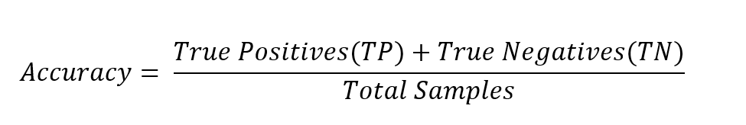

3.3.5.2 Precision: Precision indicates the accuracy of the positive predictions, showing how many of the predicted positives are positive. Which is the ratio of accurate positive discoveries to those that the classifier expected to be positive.

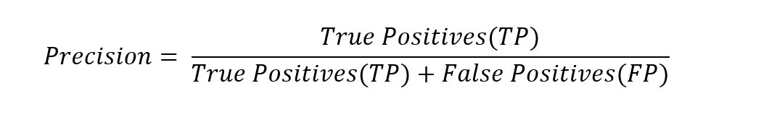

3.3.5.3 Recall (Sensitivity/True Positive Rate): This measures the proportion of actual positive instances that were correctly predicted.

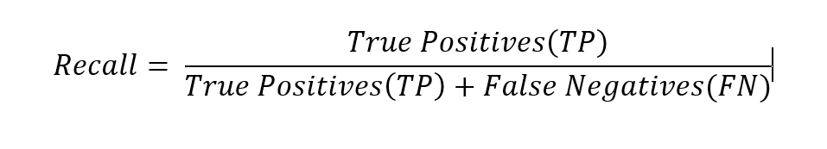 ​

3.3.5.4 F1 Score: The harmonic mean of precision and recall, which is how correctness an accuracy is. This also provides a single metric that balances both concerns.

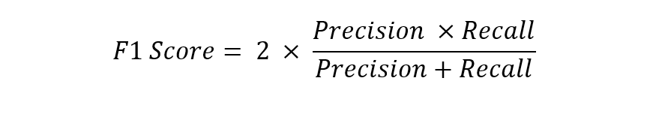

3.3.5.5 Specificity (True Negative Rate): This measures the proportion of actual negative instances of the classification models that were correctly predicted.

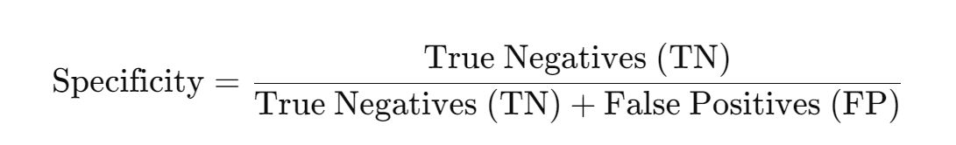

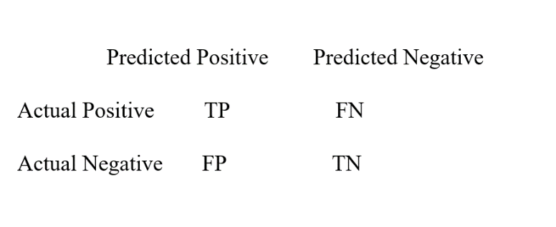3.3.5.5 Confusion Matrix: This summarizes with a matrix the performance of a classification model by showing the counts of True Positives, True Negatives, False Positives, and False Negatives. Where True Positives occur when the model correctly predicts "YES" and the actual result is also "YES." True Negatives happen when the model predicts "NO," and the actual outcome is indeed "NO." False Positives are cases where the model predicts "YES," but the actual outcome is "NO." False Negatives arise when the model predicts "NO," but the actual result is "YES."

3.3.5.6 ROC-AUC (Receiver Operating Characteristic - Area Under the Curve): this is a widely used metric for evaluating the performance of binary classification models. It represents the degree of separability and measures a model's ability to distinguish between classes. The ROC curve plots the True Positive Rate against the False Positive Rate at various threshold levels. AUC summarizes this information, with values closer to 1 indicating better performance.

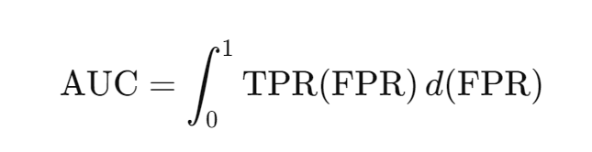

*Figure 3.3 ROC-AUC metric for prediction evaluation. (Chandola et., 2009)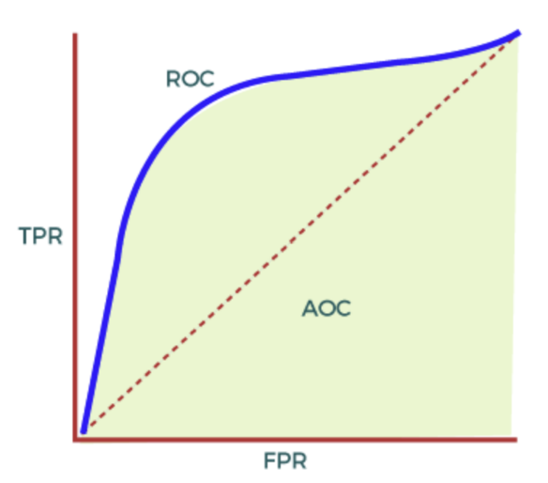*

In Figure 3.3 we see the Area Under the ROC Curve also known as AUC, represents the two-dimensional area beneath the entire ROC curve from (0,0) to (1,1). AUC evaluates how well a binary classifier performs across thresholds and gives a measure of the ROC curve. The AUC score ranges from 0 to 1 with a score indicating better model performance and clearer distinction between classes. A good model typically has an AUC value that's close to 1. See appendix 14 for full details of the code.

### **3.3.6 Stage 6: Deployment**

The Deployment stage deals with putting the project into work. At this stage, the produced system was implemented and deployed on the Heroku platform. Heroku is a cloud platform-as-a-service (PaaS) that enables developers to build, run, and manage applications entirely in the cloud. It supports multiple programming languages, including Python, Ruby, Java, Node.js, Scala, PHP, and Go, among others. Heroku simplifies the deployment process by allowing developers to push their code directly to the platform, where Heroku handles the infrastructure, scaling, and management.

To make the system user-friendly and easy to use, a page was developed using Python, HTML and CSS. The user can type in their reviews about any drug and the system analyses and gives them a sentiment output, which is either positive or negative.

# **CHAPTER 4**

# **RESULTS AND DISCUSSION**

In this chapter, it presents the outcomes of the project, such as the findings, patterns, or trends that emerged from the analysis. This focuses on facts and observations, interpretation or speculation and the implications of the results. It also covers the process for the application of sentiment analytical systems to enhance patient satisfaction on drugs using machine learning models Multinomial Naive Bayes and random forest, the comparing and evaluation of the models' performance metrics, and hyperparameter optimization.

## **4.1 DATA PREPARED:**

**Objective 1**: To design and implement an algorithm that uses Spacy Python libraries to preprocess data and understand the data, with the purpose of obtaining accurate analysable results.

The sourced data comprises of patient reviews on various drugs, with features such as Unique ID, Reviews, Ratings, Conditions, etc. To prepare this data for analysis, it is subjected to pre-processing and cleaning procedures. These steps include handling null values, removing stopwords, tokenizing the text, eliminating punctuation, applying lemmatization, converting the text to lowercase, and performing regular expression. The result is a cleaned review which is stored with the variable Cleaned_feedback.

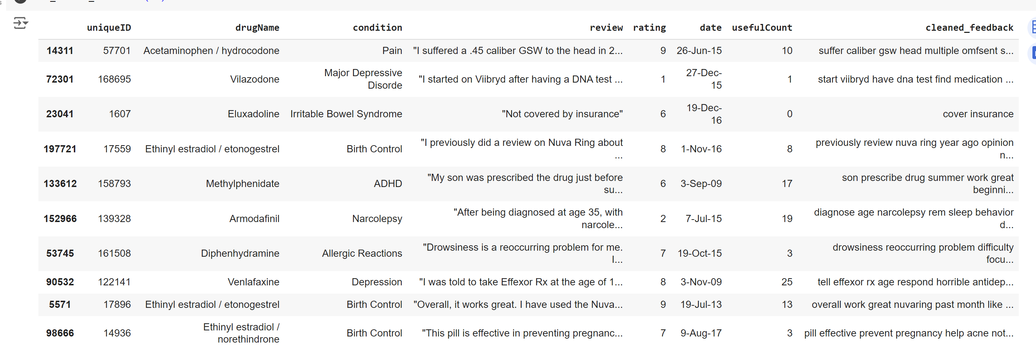

*Figure 4.1: Pre-processed Dataset*

## **4.2 SENTIMENT ANALYSIS WITH TEXTBLOB:**

Before training the classifier models, sentiment analysis was performed on the data using Textblob as part of our preparation and exploration process. This helped us explore the data by leveraging on the sentiment results.

**Objective 2**: To design and implement an algorithm that uses sentiment analysis on patient reviews on drugs to categorize the review into positive, negative, or neutral using TextBlob a python library.

Result: A dataset showing polarity which is based on sentiment score, subjectivity score, and sentiment (positive, negative and neutral) got through categorization of polarity.

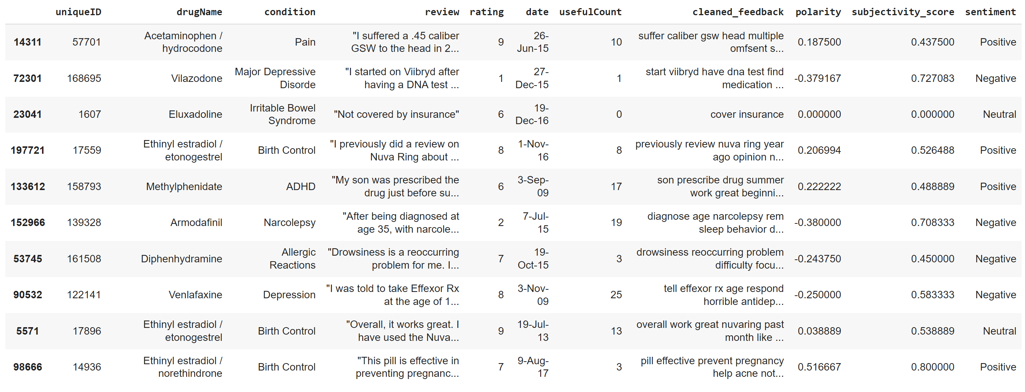

*Figure 4.2: Sentiment categorized dataset.*

## **4.3 VISUALIZATION AND EXPLORATORY DATA ANALYSIS (EDA):**

Below shows the exploratory analysis performed on the data to identify relationships and connections between variables using visualization technique.

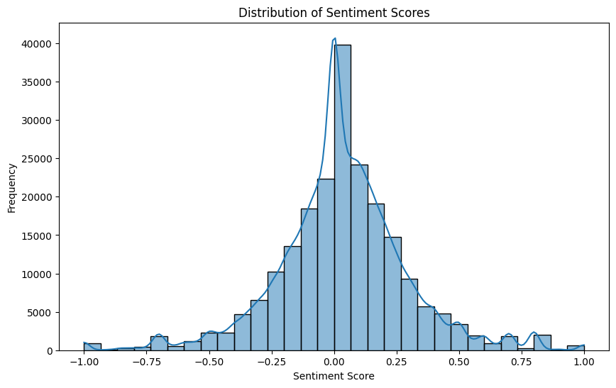

*Figure 4.3: distribution of sentiment scores(polarity)*

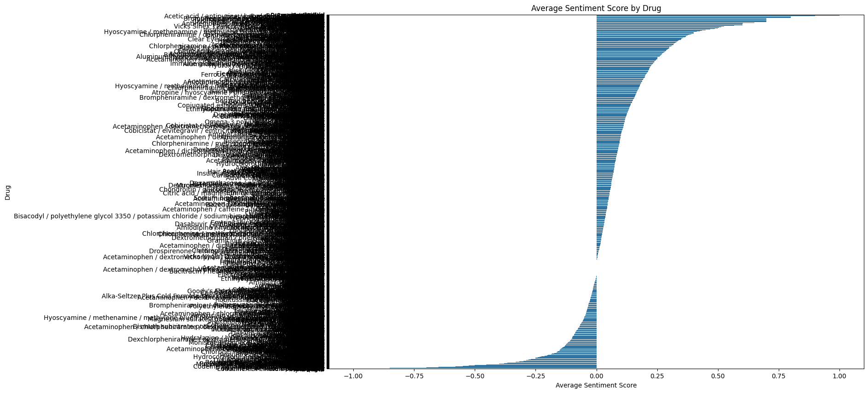

*Figure 4.4:Average sentiment score by the drug*

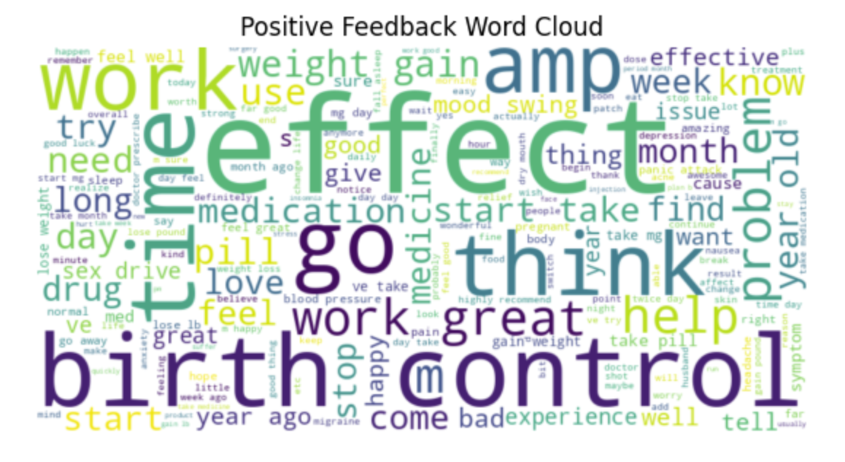

*Figure 4.5: Positive Feedback Word Cloud*

Figure 4.3 clearly demonstrates the positive Feedback words existing on the dataset.

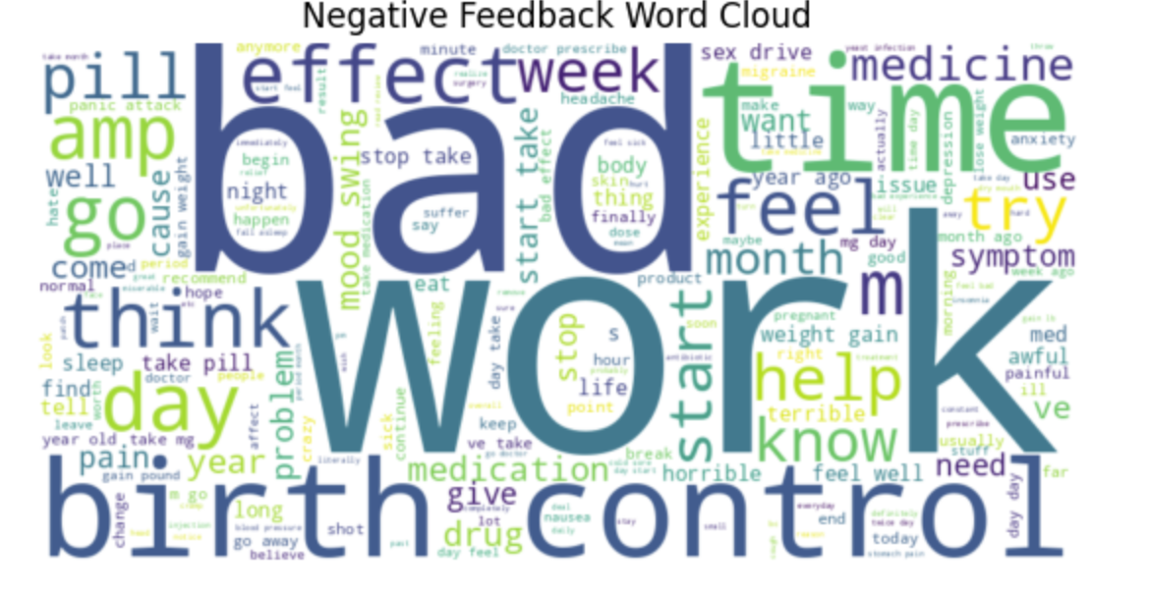

*Figure 4.6: Negative Feedback Word Cloud*

Figure 4.4 clearly demonstrates the Negative Feedback Word Cloud existing on the dataset.

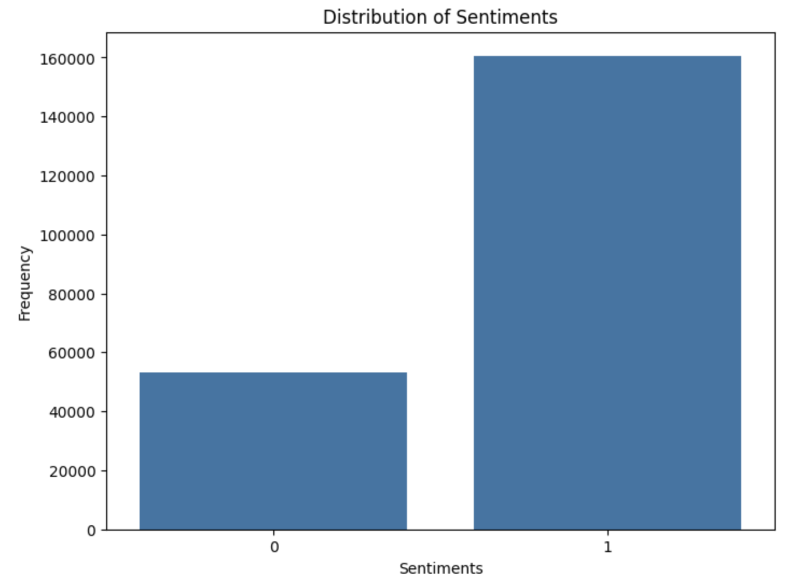

*Figure 4.7 Distribution of imbalance Textual Data*

Figure 4.5 clearly demonstrates a significant imbalance in the dataset classification, which may negatively impact the model's performance.

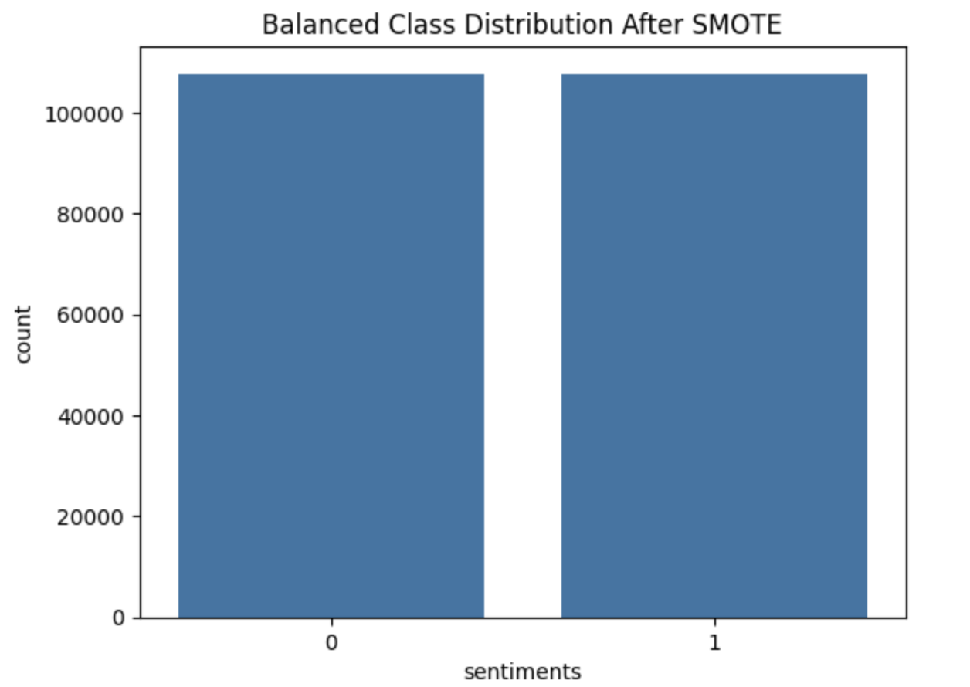

*Figure 4.8 Balance Sentiments (Label) Distribution using SMOTE.*

The principles outlined in section 3.3.3.5 were put into practice effectively in Figure 4.6. Furthermore, SMOTE achieved a distribution of sentiment classes at a 50,50 ratio. Dealing with class imbalances poses a challenge in machine learning classification scenarios where one class has notably fewer instances than the other. SMOTE (Synthetic Minority Oversampling Technique) is a common method of tackling this challenge. By creating samples through interpolation between existing ones SMOTE helps level out the distribution of classes and boosts the performance of the model.

**Objective 3:** To design an algorithm that trains the naïve bayes classifier and Random Forest Classifier from scratch and compare them based on their metrics.

## **4.4 COMPARE THE MODELS USING THE METRICS:**

Multinomial Naïve Bayes and Random Forest Classifier are Supervised machine learning classification models used in performing sentiment analysis on people’s reviews and emotions. These were used to train patient’s reviews on drugs.

### **4.4.1 Baseline Model:**

Random Forest Classifier (RFC) is considered the baseline model because it has lower performance across most metrics. Although RFC is more complex, its lower performance means that MNB should be compared against it to demonstrate improvement.

**Table 4.1: Metrics result of the baseline model (RFC)**

|  |  |  |  |  |
| --- | --- | --- | --- | --- |
| Accuracy | Precision | Recall | Specificity | F1 Score |
| 0.70 | 0.81 | 0.81 | 0.81 | 0.37 |

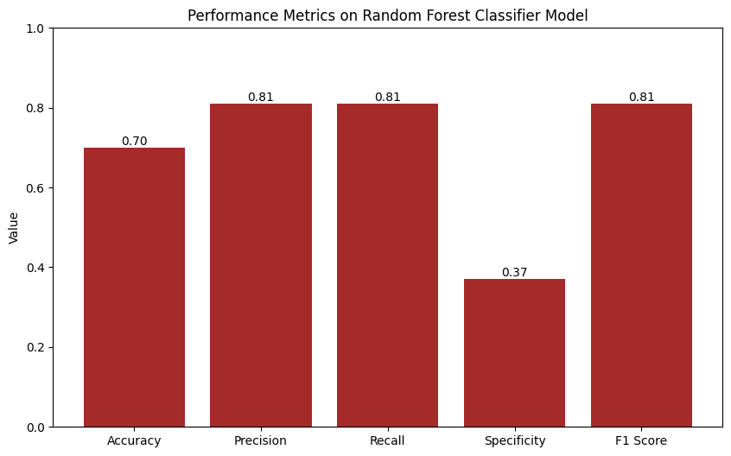

*Figure 4.9 Quantitative assessment metrics for the baseline model RFC*

The metrics performance of the baseline Random Forest Classifier result presented an accuracy of 0.70. The model correctly predicted 70% of overall instances overall. Both precisions, recall and F1 Score are relatively high at 0.81, indicating that the model is effective at identifying positive cases and making correct positive predictions. However, the model's **specificity** is low at **0.37**, indicating it struggles to correctly classify negative instances. While the high precision and recall suggest that the model balances false positives and false negatives well, the low specificity highlights a significant weakness in identifying negative instances. This could be an issue especially where avoiding false positives is critical, such as in a drug recommendation system or fraud detection. Overall, while the model performs well in the positive class, further tuning or adjustments in the dataset may be necessary to improve its performance in the negative class.

4.4.1.1 Training the two models with 10,000 samples of the dataset to see their performance in correctly performing prediction using the metrics below:

**Table 4.2: Confusion Matrix using 10,000 Samples of dataset:**

|  |  |  |  |  |
| --- | --- | --- | --- | --- |
| Classifiers/Confusion Matrix | TN | FN | TP | FP |
| Multinomial Naïve Bayes (MNB) | 541 | 634 | 1873 | 235 |
| Random Forest Classifier (RFC) | 173 | 294 | 1229 | 294 |

Given the above table, True Negatives (TN) of RFC = 173 and True Negative (TN) of MNB = 541 involve where the model correctly predicted the negative class. False Negatives (FN) of RFC = 294 and False Negatives (FN) of MNB = 634 is a scenario where the model incorrectly predicted the negative class meaning that the actual class was positive. True Positives (TP) of RFC = 1229 and True Positives (TP) of MNB = 1873 are a scenario where the model correctly predicted the positive class. False Positives (FP) of RFC = 294 and False Positives (FP) of MNB = 235 involve a scenario where the model incorrectly predicted the positive class meaning the actual class was negative.

On calculating the metrics of the trained dataset across the two models using the formulae in the methodology, the following were the results of the metrics:

**Table 4.3: Metrics results of the two ML models for comparison**

|  |  |  |  |  |  |
| --- | --- | --- | --- | --- | --- |
| Classifiers/Metrics | Accuracy | Precision | F1 Score | Recall | Specificity |
| Multinomial Naïve Bayes | 0.74 | 0.89 | 0.81 | 0.75 | 0.70 |
| Random Forest Classifier | 0.70 | 0.81 | 0.81 | 0.81 | 0.37 |

To address the research question, "How do model performance metrics (e.g., precision, recall, F1-score) differ between the two machine learning models when applied to patient drug satisfaction analysis?"

Comparing the metrics of the Multinomial Naïve Bayes and Random Forest Classifier models based on the results provided above, the Multinomial Naïve Bayes model shows accuracy at 0.74, which indicates that it correctly classifies a portion of instances compared to the Random Forest Classifier at 0.70. This implies that the Naïve Bayes model is generally more reliable overall when analysing patient drug satisfaction data. In terms of precision, which measures how accurately the models identify true positives, the Multinomial Naïve Bayes model also excels with a precision score of 0.89 surpassing the Random Forest Classifier's 0.81. This suggests that Naïve Bayes model performs better in predicting patient satisfaction when it identifies a positive outcome. However, in terms of recall the Random Forest Classifier slightly outperforms the Naïve Bayes model (0.81, vs. 0.75). Recall measures how well a model identifies all positives; thus, in this scenario the Random Forest model is superior at identifying all satisfied patients even though it may misclassify some unsatisfied patients as satisfied individuals as well. Both models share an identical F1 Score of 0.81 which balances precision and recall effectively and indicates that despite variations in precision and recall values between them both models present similar overall performance levels in achieving this balance. The Multinomial Naïve Bayes model shows a higher level of specificity (0.70) compared to the Random Forest Classifier (0.37) indicating that the Naïve Bayes model excels at correctly identifying dissatisfied patients. This ability is vital for correctly identifying individuals who are not satisfied with their medication.

The calculated metrics data above indicates that the multinomial Naïve Bayes classifier performs better than the random forest classifier model by 4 % accuracy in predicting positive and negative classes. Nevertheless, there are opportunities for enhancement based on the values.

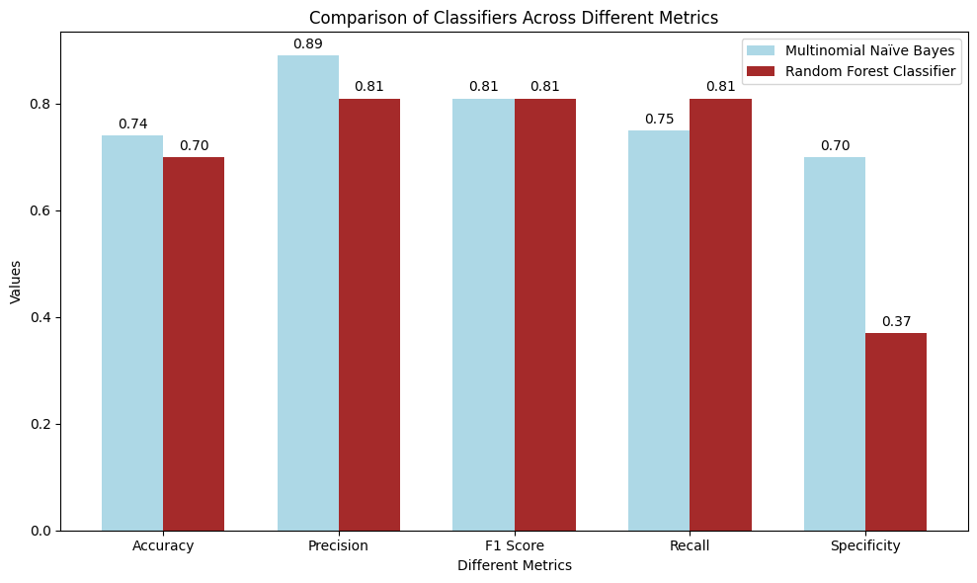

*Figure 4.10: Comparative analysis of the classifiers across different metrics.*

4.4.1.2 Training with a larger dataset to aid in improving the performance of the baseline model.

**Table 4.4: Confusion Matrix for the two models using 20,000 Samples of dataset**

|  |  |  |  |  |
| --- | --- | --- | --- | --- |
| Classifiers/Confusion Matrix | TN | FN | TP | FP |
| Multinomial Naïve Bayes (MNB) | 1148 | 1162 | 3787 | 468 |
| Random Forest Classifier (RFC) | 414 | 638 | 2361 | 566 |

From the table above, True Negatives (TN) of RFC = 414 and True Negative (TN) of MNB = 1148 involve where the model correctly predicted the negative class. False Negatives (FN) of RFC = 638 and False Negatives (FN) of MNB = 1162 is a scenario where the model incorrectly predicted the negative class meaning that the actual class was positive. True Positives (TP) of RFC = 2361 and True Positives (TP) of MNB = 3787 is a scenario where the model correctly predicted the positive class. False Positives (FP) of RFC = 566 and False Positives (FP) of MNB = 468 involve a scenario where the model incorrectly predicted the positive class meaning the actual class was negative.

Calculating the metrics of the trained dataset across the two models using the formulae in the methodology, the following includes the results of the metrics:

**Table 4.5: Metrics results of the two ML models for comparison using 20,000**

|  |  |  |  |  |  |
| --- | --- | --- | --- | --- | --- |
| Classifiers/Metrics | Accuracy | Precision | F1 Score | Recall | Specificity |
| Multinomial Naïve Bayes | 0.75 | 0.89 | 0.82 | 0.77 | 0.71 |
| Random Forest Classifier | 0.70 | 0.81 | 0.80 | 0.79 | 0.42 |

To address the research question, " How do Multinomial Naive Bayes and Random Forest Classifiers compare in terms of identifying sentiments in patient drug reviews?”

The results suggest that the **Multinomial Naïve Bayes** model performs better overall in identifying sentiments in patient drug reviews. Specifically, it has higher accuracy (0.75), indicating it correctly classifies a greater proportion of both positive and negative sentiments compared to the **Random Forest Classifier** (0.70). Precision which is the proportion of true positives out of all positive predictions that is the number of predicted positives that are truly positive for multinomial naïve bayes and random forest classifiers are 0.89 and 0.81 respectively, recall is the proportion of actual positives that are correctly identified by the model which is 0.77 and 0.79 for multinomial naïve bayes and random forest classifier respectively, specificity is the proportion of actual negatives that are correctly identified by the model which is 0.71 and 0.42 for multinomial naïve bayes and random forest classifier respectively, and lastly F1 score is the mean of precision and recall, giving a balance between the two metrics which is 0.82 and 0.80 for multinomial naïve bayes and random forest classifier respectively.

These metrics above show an improvement by training with a larger dataset, although multinomial naïve bayes is consistently outperforming random forest classifier in most metrics, particularly in accuracy which is 5% better, precision which is 8%, and specificity which is 29% better than in random forest classifier. However, there is room for improvement based on the metrics values in order to get the best and superior model.

When looking at identifying sentiments in drug reviews, the Multinomial Naïve Bayes model appears to be more effective overall. It offers accuracy, higher precision and better specificity making it a more reliable option for accurately classifying positive and negative sentiments. While the Random Forest Classifier shows an advantage in recall, the Multinomial Naïve Bayes model's balanced performance across metrics indicates that it is better suited to analysing sentiments in this area.

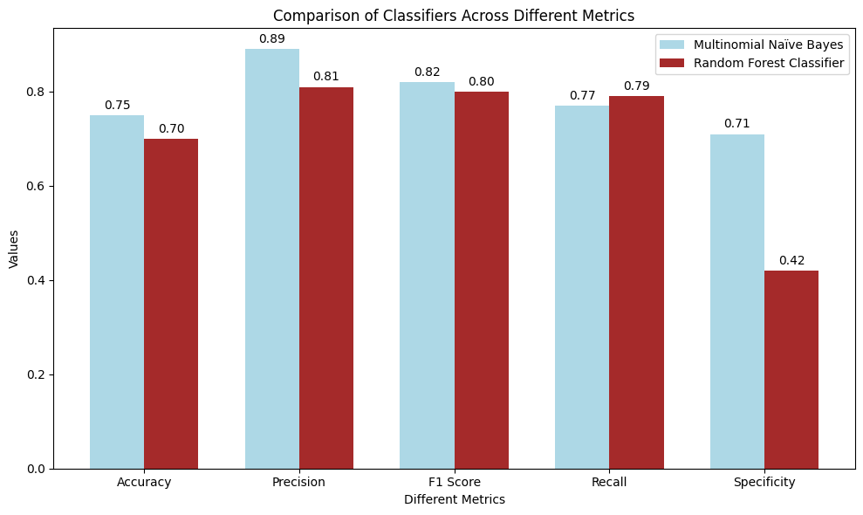

*Figure 4.11: Comparative Analysis of the classifiers across different metrics with a larger set.*

Having compared the results of the metrics above, there will not be any need to continue increasing the dataset to train the models as their performance increase is slow and Random Forest Classifier being a very complex supervised machine learning model which builds on decision trees has a long training time. However, Multinomial Naïve Bayes which is simpler and has been seen to show better performance would be improved to get the best and superior model from it.

4.4.1.3 Using the complete dataset to train multinomial naïve bayes models.

**Table 4.6: Metrics results of the Multinomial Naïve Bayes using the complete dataset:**

|  |  |  |  |  |
| --- | --- | --- | --- | --- |
| Accuracy | Precision | Recall | Specificity | F1 Score |
| 0.79 | 0.90 | 0.82 | 0.72 | 0.86 |

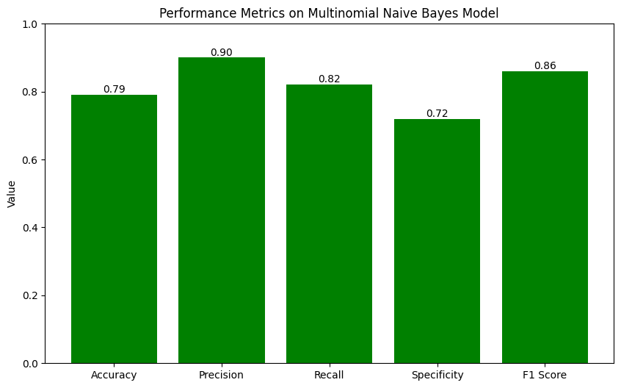

*Figure 4.12 Quantitative assessment metrics for the proposed model (MNB)*

There is a significant increase in the performance of this model in performing predictions as its accuracy and other metrics increased. An accuracy of 0.79 means that the model correctly predicted 79% of all the samples in the dataset. This is general used to measure how well the model is performing especially for a balanced class. Precision of 0.90 indicates that when the model predicts a positive class, it is correct 90% of the time. High precision means few false positives. A recall of 0.82 means that the model correctly identifies 82% of all actual positive instances. High recall means fewer false negatives. A specificity of 0.72 means that the model correctly identifies 72% of all actual negative instances. High specificity means fewer false positives. An F1 Score of 0.86 suggests a good balance between precision and recall, with the model performing well in both minimizing false positives and false negatives. However, there is room for improvement based on the metrics values in other to get the best and superior model and this leads to the performing of hyperparameter tuning on the multinomial naïve bayes.

**Objective 4**: To perform hyperparameter tuning, investigate and evaluate the metrics, and performance of the best model.

## **4.2 HYPERPARAMETER TUNING ON MULTINOMIAL NAÏVE BAYES:**

Hyperparameter tuning is a crucial step involved in optimizing the performance of a machine learning model. After identifying the best model (Multinomial Naïve Bayes) adjusting its hyperparameters can help achieve better accuracy, and efficiency.

**Table 4.7: Hyperparameter tuning of Multinomial Naïve Bayes Model**

|  |  |  |  |  |  |
| --- | --- | --- | --- | --- | --- |
| Hyperparameter (Alpha) | Accuracy | Precision | F1 Score | Recall | Specificity |
| None | 0.79 | 0.90 | 0.86 | 0.82 | 0.72 |
| 0.5 | 0.80 | 0.90 | 0.86 | 0.83 | 0.71 |
| 0.1 | 0.81 | 0.90 | 0.87 | 0.85 | 0.70 |
| 0.05 | 0.81 | 0.90 | 0.87 | 0.85 | 0.70 |
| 0.01 | 0.82 | 0.89 | 0.87 | 0.86 | 0.70 |
| 0.005 | 0.82 | 0.89 | 0.87 | 0.86 | 0.69 |

To answer the research question, "What impact does hyperparameter tuning have on the performance of the best model?", the table and analysis above illustrate how adjusting the alpha parameter impacts the model's performance metrics. This was achieved using the Grid Search function. Hyperparameter tuning, specifically lowering the alpha value, positively affects the accuracy of the model, improving it from 0.79 (no tuning) to 0.82 when the alpha is set to 0.01 or 0.005. This suggests that fine-tuning alpha helps the model correctly classify more instances overall. Similarly, recall, which measures the model's ability to correctly identify actual positives, improves from 0.82 to 0.86 at lower alpha values. This improvement indicates that the model becomes more effective at identifying true positives, meaning it is better at predicting patient satisfaction accurately. The F1 score also increases slightly from 0.86 to 0.87 as alpha decreases, demonstrating a better balance between precision and recall after tuning. However, specificity decreases slightly from 0.72 to 0.69, indicating that while the model becomes better at identifying positives, it slightly sacrifices its ability to correctly identify negatives. In conclusion, hyperparameter tuning, specifically adjusting the alpha value, enhances the model's overall performance by increasing accuracy, recall, and F1 score. Although there is a small trade-off in specificity, an alpha value between 0.01 and 0.005 appears optimal, striking a balance between improved performance and precision. This tuning process refines the model, making it more effective in predicting patient satisfaction, thus confirming that fine-tuning alpha positively impacts the model's ability to correctly classify overall.

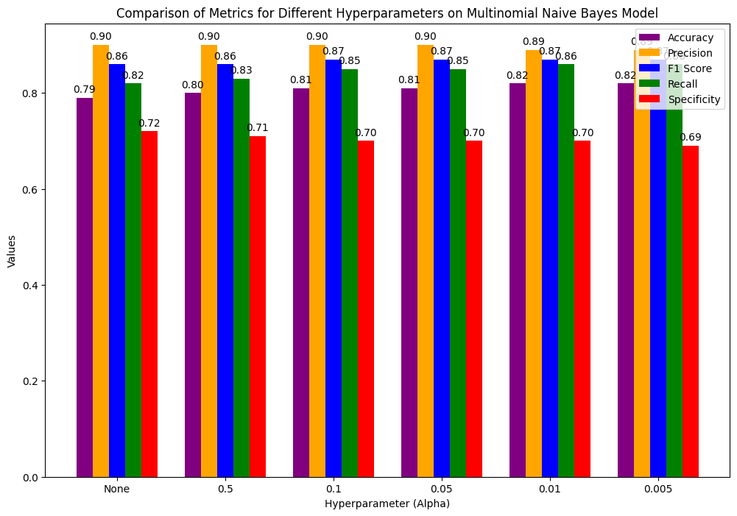

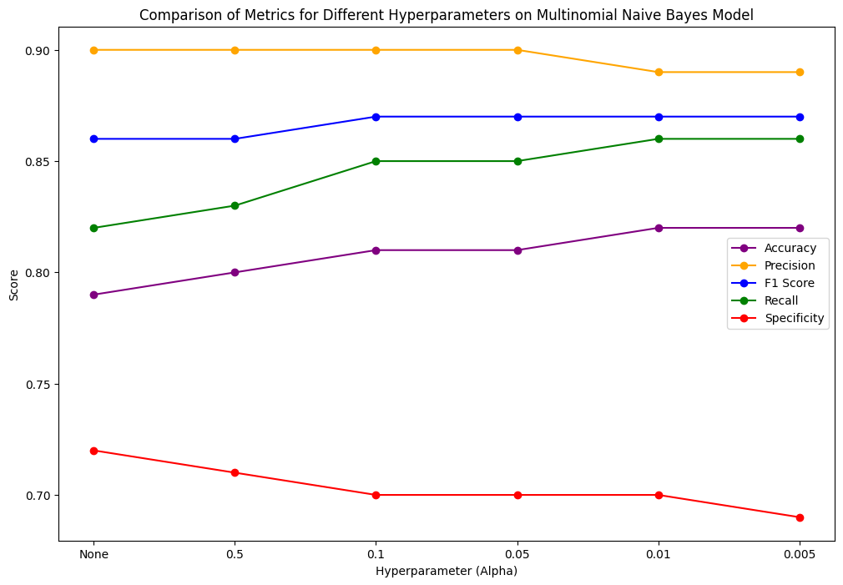*Figure 4.13: Bar Chart showing the metrics of the hyperparameter tuning on Multinomial Naïve Bayes*

*Figure 4.14: Line Chart showing the various metrics result of hyperparameters tuning on Multinomial Naïve Bayes (Best Model)*

The line chart above shows better comparison of the trend on performing hyperparameter tuning on Multinomial Naïve bayes model.

**Objective 5:** Compare the performance and efficiency of the best model with that of other models.

**Table 4.8: shows the performance comparison of the proposed model with the other existing models.**

|  |  |  |  |  |
| --- | --- | --- | --- | --- |
| Name | System built | Dataset | Model Used | Accuracy |
| Muhammad Yusril Helmi Setyawan, Rolly Maulana Awangga, Safif Rafi Efendi | Comparison Of Multinomial Naive Bayes Algorithm and Logistic Regression For Intent Classification In Chatbot | 83,495 tweets related to HIV and AIDS. | Multinomial Naïve Bayes | 0.6364 |
| Dharmendrasinh Rathod; Kashyap Patel; Akashgiri Jashvantgiri Goswami; Sheshang Degadwala; Dhairya Vyas | Exploring Drug Sentiment Analysis with Machine Learning Techniques | Drug reviews from online forums, social media platforms, or medical websites. | Naïve Bayes | 76% |
| Raja Marappan, S. Bhaskaran, S. Ashwadh, and H. Aathi Raj | Extraction of Drug Review Polarity Using Sentimental Analysis | 20 Newsgroups Dataset | Naive Bayes | 75.2% |
| Raja Marappan, S. Bhaskaran, S. Ashwadh, and H. Aathi Raj | Extraction of Drug Review Polarity Using Sentimental Analysis | 20 Newsgroups Dataset | XG-Boost | 79.2% |
| Muhammad Yusril Helmi Setyawan, Rolly Maulana Awangga, Safif Rafi Efendi | Comparison Of Multinomial Naive Bayes Algorithm And Logistic Regression For Intent Classification In Chatbot | 83,495 tweets related to HIV and AIDS. | Logistic Regression | 0.73 |
| Proposed Model by Nneoma Nnorom | Sentiment Analytical System to enhance patient satisfaction on drugs. | Drug Review Dataset (Drugs.com) from UCI ML repository | Multinomial Naïve Bayes | 0.82 |

The data, in the table above presents a comparison of different models and methods based on their performance metrics, model complexity and scalability. It can be inferred that the proposed model (Sentiment Analytical system for enhancing satisfaction with drugs) achieved the accuracy of 0.82 in terms of performance metrics. In the task the XG Boost model outperformed a Naive Bayes model with accuracies of 79.2% and 75.2% respectively indicating that XG Boost may deliver performance in specific scenarios. Logistic Regression also proved its effectiveness by attaining an accuracy of 73% on an 83,495 tweet dataset surpassing Naive Bayes accuracy of 63.64% on the dataset. In terms of model complexity Naive Bayes models are generally simpler and less computationally intensive compared to models such as Logistic Regression or XG Boost. They are easy to implement and demand fewer resources. Logistic Regression is more complex than Naive Bayes as it involves parameter optimization but remains relatively straightforward and understandable. XG Boost is more complex because it involves boosting techniques that combine weak learners to form a robust model. Lastly, when considering scalability, Naive Bayes models excel because of their simplicity and efficiency, with large datasets.

Logistic Regression can handle datasets effectively. It needs more resources. On the hand XG Boost despite its strength is less scalable, due to its complexity and higher computational requirements. Overall, the proposed model stands out as the best overall outperforming the other models.

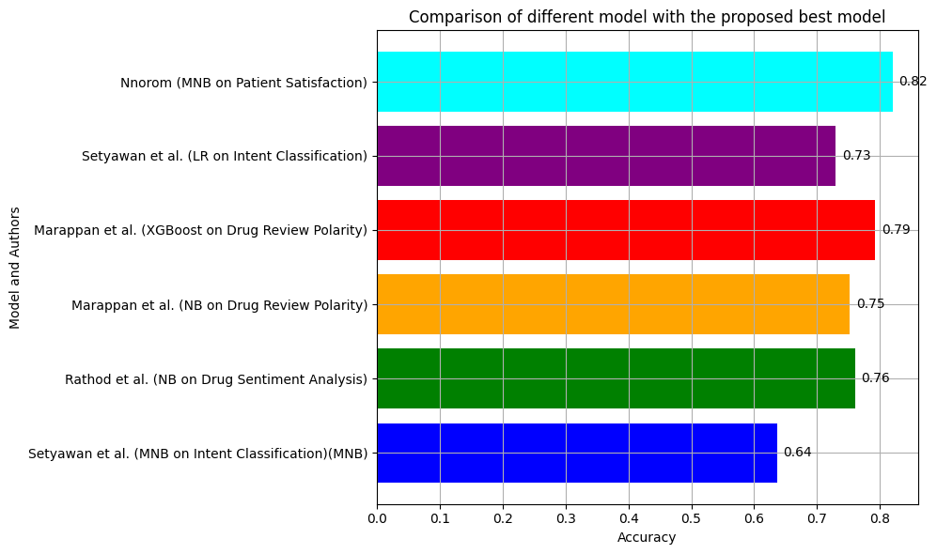

*Figure 4.15 shows the chart of the comparison of the different existing model with the proposed model.*

**Objective 6**: To design a User Interface to enable interaction with the model.

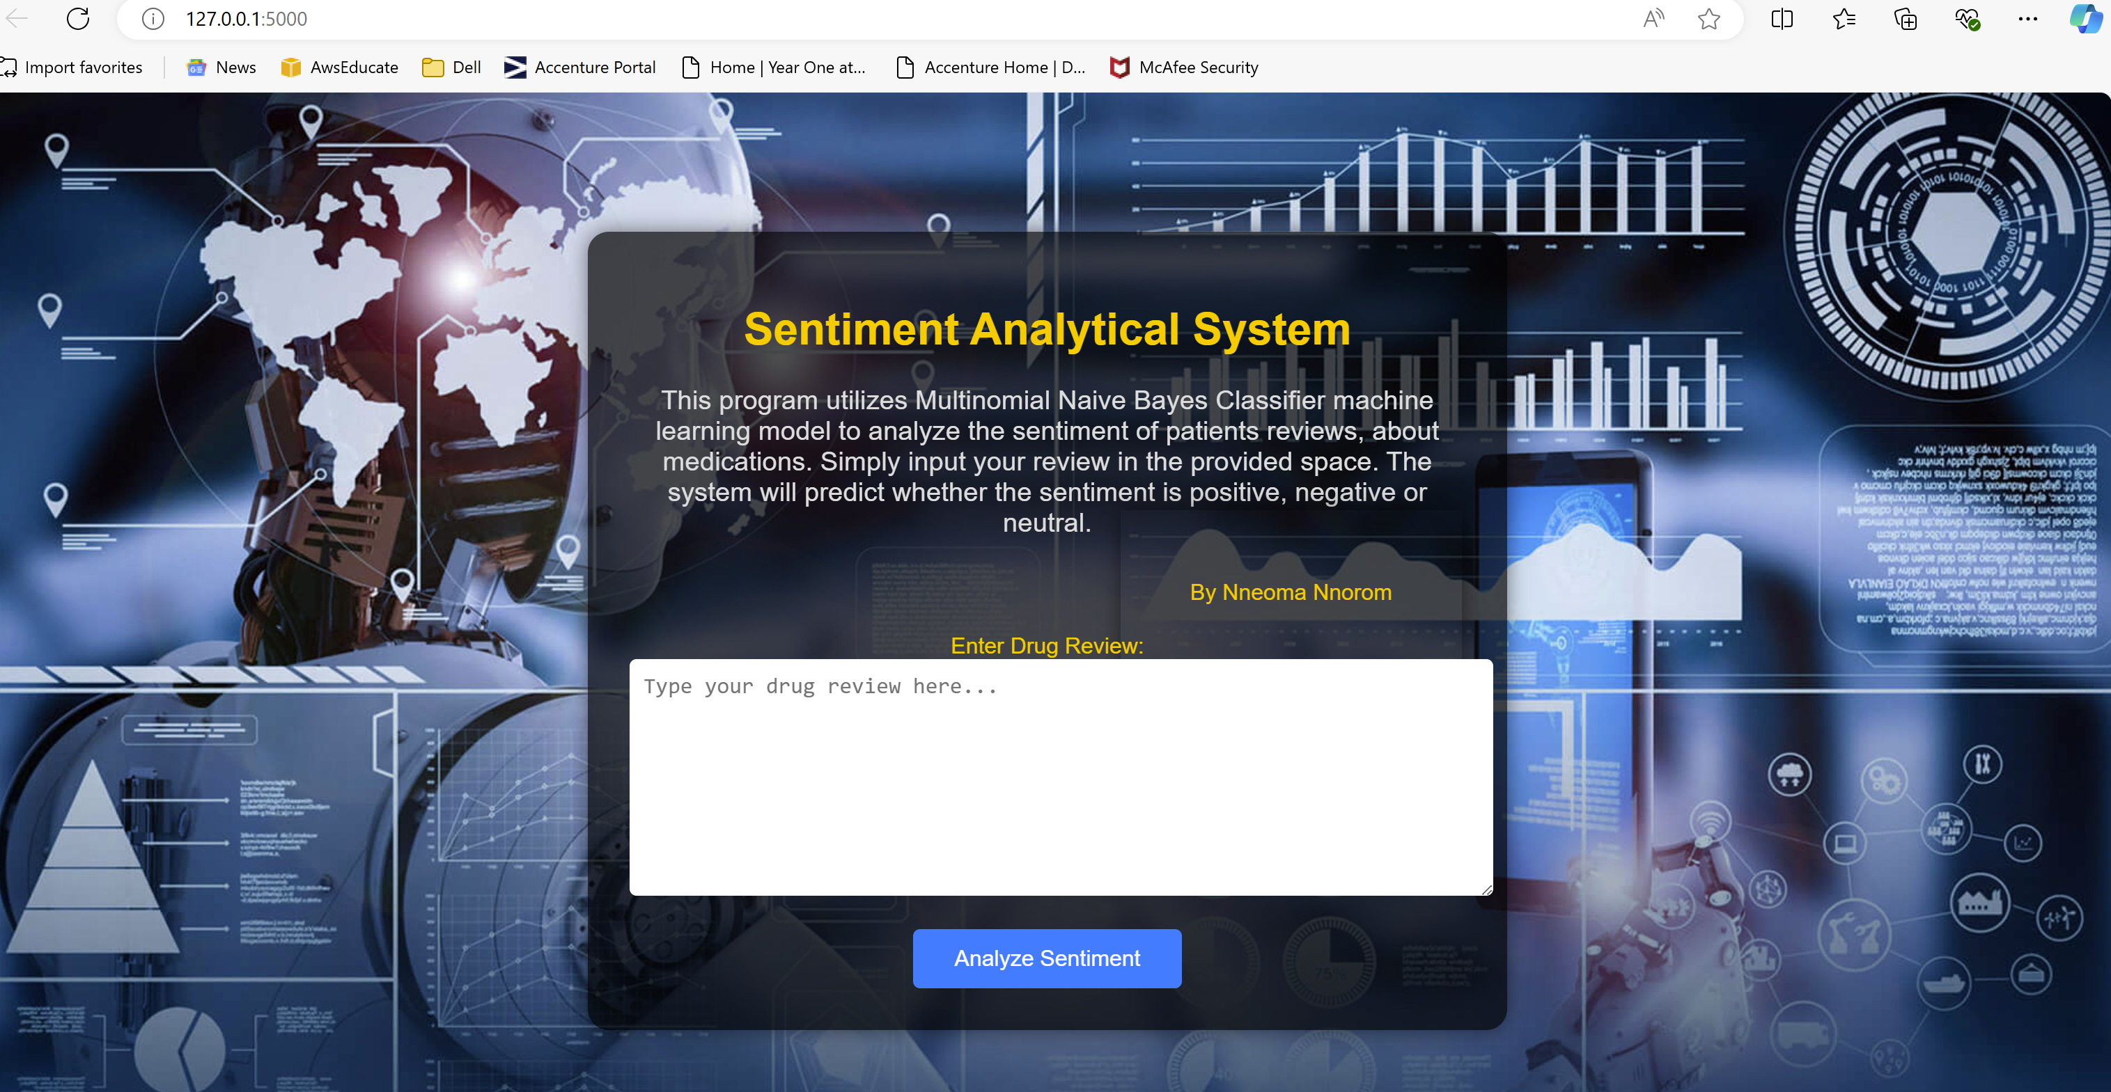

*Figure 4.16 first page of the user interface*

The figure 4.14 above shows the first page of the Sentiment Analytical System for enhancing patient satisfaction on drug with a textbox that accepts patient’s reviews. This was designed with HTML and CSS. The code for implementation is found in the appendix.

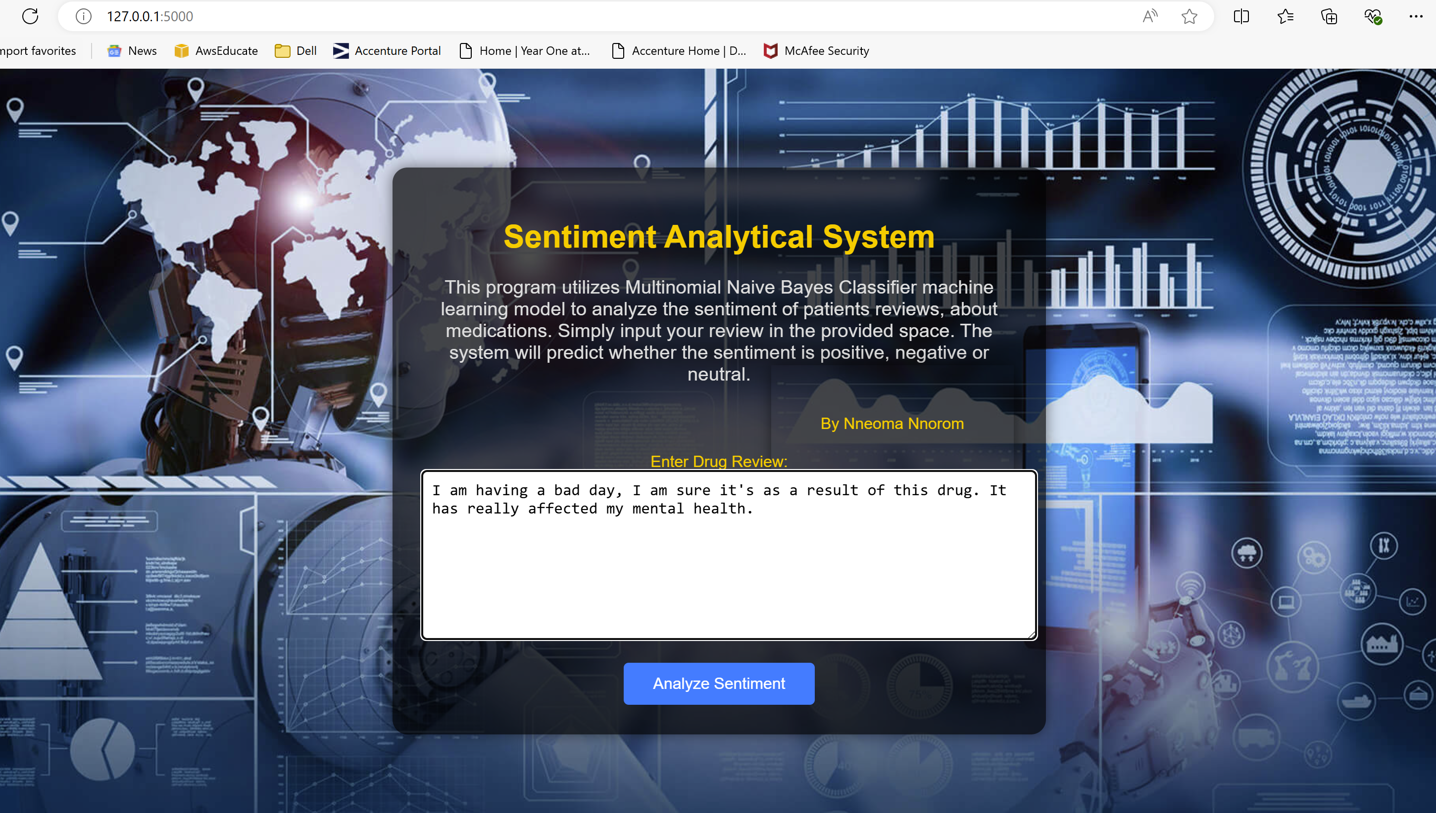

*Figure 4.17 shows the written review yet to be analysed.*

Figure 4.15 shows the interface with patient’s review before carrying out its sentiment analysis.

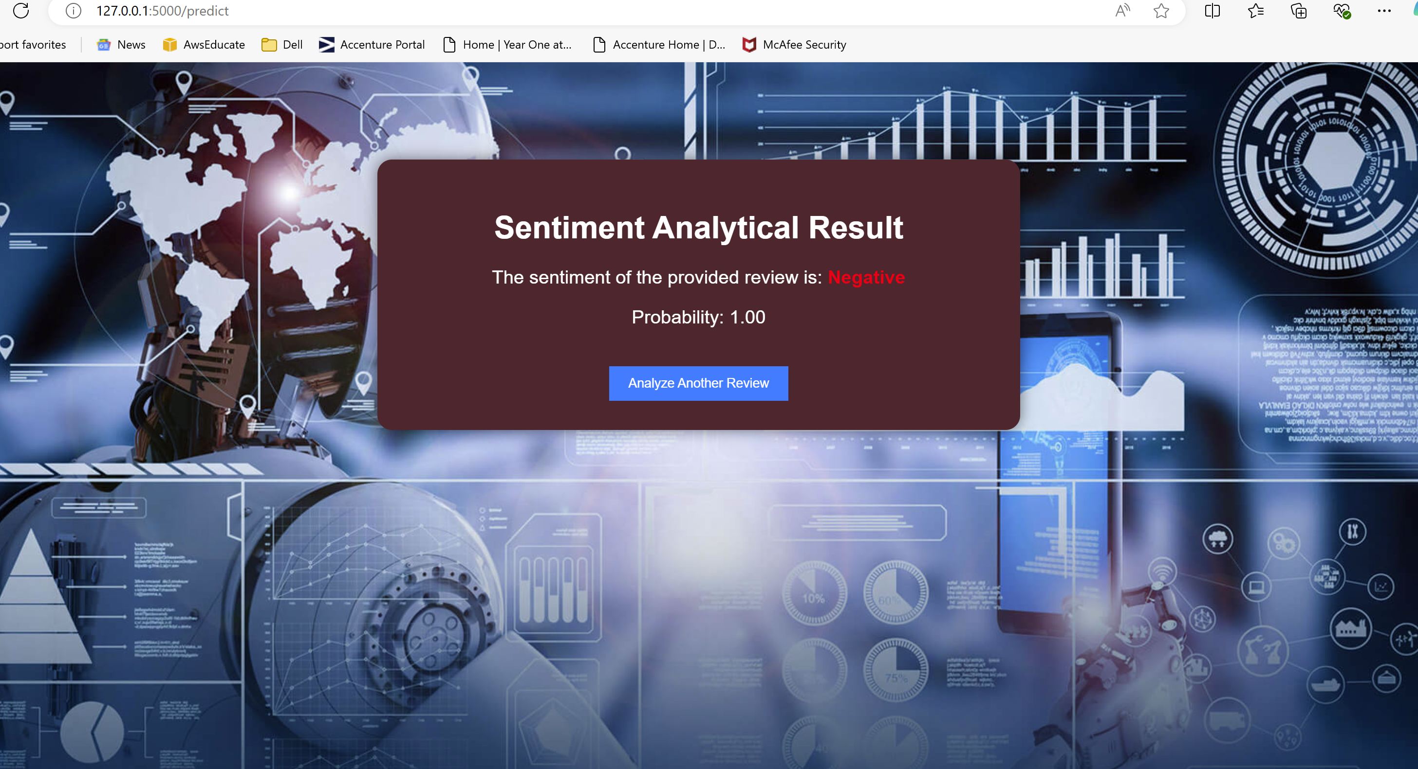

*Figure 4.18 shows the result of the analysed review.*

Figure 4.18 shows the sentiment result of the analysed review and the prediction probability which gives insight on the patient’s emotion about any drug, and a button to redirect you to the first page where you can add more reviews.

# **CHAPTER FIVE:**

# **CONCLUSION AND RECOMMENDATION**

## **5.1 CONCLUSION:**

This project met its primary aims by demonstrating the applicability of sentiment analysis to enhancing patient satisfaction with drugs through classification of sentiment. The successful deployment of the MNB model aligns with the objective of utilizing machine learning to improve healthcare outcomes. The application of a sentiment analytical system using the Multinomial Naive Bayes (MNB) model to enhance patient satisfaction with drugs has yielded promising results. After the comparison of the two models Multinomial naïve bayes and random forest classifier (baseline model), multinomial naïve bayes classifier outperformed RFC which is very complex. Multinomial naïve bayes which is seen as the best model was hyper-tuned to further improve its performance. The model successfully classified patient sentiments into positive, negative, and neutral with a high level of accuracy, demonstrating its potential for identifying sentiments related to drug overall satisfaction. These findings provide valuable insights into patient experiences, answer the research questions as clearly explained in chapter 4, and can help healthcare providers and pharmaceutical companies tailor their approaches to patient care.

Comparing to recent literature, the results of this research align with previous studies that highlighted the effectiveness of machine learning models, particularly Multinomial Naïve Bayes (MNB) with less complexity and high scalability in sentiment analysis. While other research often focuses on broader applications like general healthcare sentiments, this study specifically targets patient satisfaction with drugs presenting a unique contribution to the field. Although the model’s performance is commendable, there is potential for enhancement by integrating MNB with algorithms to boost capabilities as recommended in recent literature.

Overall, this sentiment analysis approach could have a significant impact on healthcare by providing actionable insights to enhance patient satisfaction, but it requires careful implementation, ethical oversight, and continuous monitoring.

## **5.2 RECOMMENDATION:**

To enhance the sentiment analytical system's accuracy and reliability, it is recommended to improve the dataset used for training the MNB model. This could involve incorporating domain-specific lexicons and synonym dictionaries to help the model better understand medical terminology and context. To fully utilize the sentiment analytical systems benefits, it is advised to integrate its outcomes into healthcare platforms, like EHRs. This integration would enable healthcare professionals to access sentiment data alongside information offering a comprehensive view of patient satisfaction. Limitations include the complexity of RFC model training due to the very large datasets and acknowledges the need for further refinement in data handling and model accuracy.

**5.2.1 Further Work:** Future work could involve experimenting with various machine learning methods, like deep learning to further enhance the model's performance. Having enough resources for model training would ensure that the model is properly trained and hyperparameters are adjusted, if necessary, without causing resource challenges or a longer run time. Furthermore, incorporating sentiment analysis into feedback systems might offer nuanced perspectives on patient happiness allowing for quicker reactions to needs.

# **REFERENCES**

Syed, I. and Lokhande, V. (2024) 'AN OVERVIEW OF THE SUPERVISED MACHINE LEARNING,' International Research Journal of Modernization in Engineering Technology and Science [Preprint]. <https://doi.org/10.56726/irjmets51366>.

Sivaiah, B. et al. (2024) 'Drug Recommendation System on Sentiment Analysis of Drug Reviews by Using Machine learning,' International Journal for Research in Applied Science and Engineering Technology, 12(3), pp. 20192023. <https://doi.org/10.22214/ijraset.2024.59247>.

Yadav, N.R.K., Madaan, N.A. and Janu, N. (2024) 'Comprehensive analysis of natural language processing,' Global Journal of Engineering and Technology Advances, 19(1), pp. 083090. <https://doi.org/10.30574/gjeta.2024.19.1.0058>.

Dande, N.A.A. and Pund, N.Dr.M.A. (2023) 'A review study on Applications of Natural Language Processing,' International Journal of Scientific Research in Science Engineering and Technology, pp. 122126. <https://doi.org/10.32628/ijsrset2310214>.

Ekins, S., Puhl, A.C., Zorn, K.M. et al. Exploiting machine learning for end-to-end drug discovery and development. Nat. Mater. 18, 435–441 (2019). <https://doi.org/10.1038/s41563-019-0338-z>

Cho, J. et al. (2024) 'Development of machine-learning models using pharmacy inquiry database for predicting dose-related inquiries in a tertiary teaching hospital,' International Journal of Medical Informatics, 185, p. 105398. <https://doi.org/10.1016/j.ijmedinf.2024.105398>.

Garg, S., 2024. Drug Recommendation System based on Sentiment Analysis of Drug Reviews using Machine Learning. Journal of Healthcare Informatics

Sindhu, S., Kumar, S. and Noliya, A. (2023c) 'A Review on Sentiment Analysis using Machine Learning,' <https://doi.org/10.1109/ICIDCA56705.2023.10099665>.

Hameed, M.A.-A.A., Shaker, K. and Khalaf, H.A. (2023b) 'Sentiment Classification of Drug Reviews Using Machine Learning Techniques,' International Conference on Developments in eSystems Engineering [Preprint]. <https://doi.org/10.1109/dese58274.2023.10099735>.

Khan, H.F. and Fatima, N. (2023b) 'Analyzing Customer Sentiment in Drug Reviews Using Natural Language Processing,' 7th International Conference on Electronics, Materials Engineering & Nano-Technology (IEMENTech) [Preprint]. <https://doi.org/10.1109/iementech60402.2023.10423529>.

Hiremath, B.N. and Patil, M.M. (2022) 'Enhancing Optimized Personalized Therapy in Clinical Decision Support System using Natural Language Processing,' Journal of King Saud University - Computer and Information Sciences, 34(6), pp. 2840–2848. <https://doi.org/10.1016/j.jksuci.2020.03.006>.

Nalini, C. et al. (2023) 'Review on sentiment analysis using supervised machine learning techniques,' in Lecture notes in networks and systems, pp. 166–177. <https://doi.org/10.1007/978-3-031-35507-3_17>.

Iqbal, R., Umar, A.I. & Almohsen, H., 2023. Drug Sentiment Analysis Using Machine Learning Classifiers. Available at: <https://www.arxiv.org/abs/2303.07403>

Wankhade, M., Rao, A.C.S. and Kulkarni, C. (2022b) 'A survey on sentiment analysis methods, applications, and challenges,' Artificial Intelligence Review, 55(7), pp. 5731–5780. <https://doi.org/10.1007/s10462-022-10144-1>.

Sindhu, S., Kumar, S. and Noliya, A. (2023) 'A Review on Sentiment Analysis using Machine Learning,' International Conference on Innovative Data Communication Technologies and Application (ICIDCA) [Preprint]. <https://doi.org/10.1109/icidca56705.2023.10099665>.

Murugeswari, R. et al. (2022) 'Machine Learning based Omnifood: Nutritional Meal Drop,' 2022 4th International Conference on Inventive Research in Computing Applications (ICIRCA) [Preprint]. <https://doi.org/10.1109/icirca54612.2022.9985535>.

Helae, M., Ebrahimi, D., & Alzhouri, F. (2022). Data Analytics in the Pharmacology Domain. International Journal of Big Data and Analytics in Healthcare.

Abdulkareem, N.M. and Abdulazeez, A.M. (2021) 'Machine Learning Classification based on Radom Forest Algorithm: a review,' International Journal of Science and Business, 5(2), pp. 128–142. <https://doi.org/10.5281/zenodo.4471118>.

Kaur, M., Singh, J., and Grewal, G., 2021. Comparison between Multinomial Naive Bayes and Multi-Layer Perceptron for Product Review In Real Time. *International Journal of Scientific & Engineering Research*, 12(9), pp.71-79.

Bagwan, A. A., Ganage, A. V., Yedge, A. B., & Shewale, Y. P. (2021). Patient feedback system using sentimental analysis. International Journal of Innovative Research in Science, Engineering and Technology, 10(6), 7711-7718. DOI:10.15680/IJIRSET.2021.1006309.

Pandey, S., M, S. and Shrivastava, A. (2017) 'Data classification using machine learning approach,' in Advances in intelligent systems and computing, pp. 112–122. <https://doi.org/10.1007/978-3-319-68385-0_10>.

Paul, A. et al. (2018) 'Improved random forest for classification,' IEEE Transactions on Image Processing, 27(8), pp. 4012–4024. <https://doi.org/10.1109/tip.2018.2834830>.

Xu, S., Li, Y. and Wang, Z. (2017) 'Bayesian multinomial naïve Bayes classifier to text classification,' in Lecture notes in electrical engineering, pp. 347–352. <https://doi.org/10.1007/978-981-10-5041-1_57>.

Mishra, B.K., & Kumar, R. (2020). Natural Language Processing in Artificial Intelligence (2020b) Apple Academic Press eBooks. <https://doi.org/10.1201/9780367808495>.

Vermeulen, A.F. (2020) 'Supervised learning: using labeled data for insights,' in Apress eBooks, pp. 63–136. <https://doi.org/10.1007/978-1-4842-5316-8_4>.

Basavaraju, P., & Varde, A.S. (2017). Supervised Learning Techniques in Mobile Device Apps for Androids. SIGKDD Explor., 18, 18-29.

Cunningham, P., Cord, M. and Delany, S.J. (2008) 'Supervised learning,' in Springer eBooks, pp. 21–49. <https://doi.org/10.1007/978-3-540-75171-7_2>.

I. Muhammad and Z. Yan, “SUPERVISED MACHINE LEARNING APPROACHES: A SURVEY.,” in ICTACT J. Soft Comput., vol. 5, no. 3, 2015.

Purwono, P., Wirasto, A. and Nisa, K. (2021) 'Comparison of machine learning algorithms for classification of drug groups,' SISFOTENIKA, 11(2), p. 196. <https://doi.org/10.30700/jst.v11i2.1134>.

Tufail, S., Riggs, H., Tariq, M., & Sarwat, A. I., 2023. Advancements and Challenges in Machine Learning: A Comprehensive Review of Models, Libraries, Applications, and Algorithms. Electronics, 12(17), p.1789. <https://doi.org/10.3390/electronics12101789>.

Priya, N., & Shobana, G. (2019). Application of Machine Learning Models in Drug Discovery: A Review.

C.D. Manning, P. Raghavan and H. Schuetze (2008). Introduction to Information Retrieval. Cambridge University Press, pp. 234-265. <https://nlp.stanford.edu/IR-book/html/htmledition/naive-bayes-text-classification-1.html>

Yadav, A. and Vishwakarma, D.K. (2020b) 'A Weighted Text Representation framework for Sentiment Analysis of Medical Drug Reviews,' International Conference on Multimedia Big Data [Preprint]. <https://doi.org/10.1109/bigmm50055.2020.00057>.

Najjar, E., & Breesam, A. M. (2023). Supervised Machine Learning: A Brief Survey of Approaches1. Al-Iraqia Journal for Scientific Engineering Research, 2(4), 71-82. <http://doi.org/10.58564/IJSER.2.4.2023.121>.

Mosavi, A., Salimi, M., Faizollahzadeh Ardabili, S., Rabczuk, T., Shamshirband, S., & Varkonyi-Koczy, A.R., 2019. State of the art of machine learning models in energy systems, a systematic review. Energies, 12(7), p.1301. <https://doi.org/10.3390/en12071301>.

Saravanan, R. & Sujatha, P., 2018. A State of Art Techniques on Machine Learning Algorithms: A Perspective of Supervised Learning Approaches in Data Classification. 2018 Second International Conference on Intelligent Computing and Control Systems (ICICCS). IEEE. <https://doi.org/10.1109/ICCONS.2018.8663155>.

Taboada, M. (2016) 'Sentiment Analysis: An Overview from Linguistics,' Annual Review of Linguistics, 2(1), pp. 325–347. <https://doi.org/10.1146/annurev-linguistics-011415-040518>.

Bird, S., Klein, E., & Loper, E. (2009) Natural language processing with Python. United States: O'Reilly Media

Schommer, J.C., Kucukarslan, S.N., & Kucukarslan, S.N. (1997). Measuring patient satisfaction with pharmaceutical services. American journal of health-system pharmacy : AJHP : official journal of the American Society of Health-System Pharmacists, 54 23, 2721-32; quiz 2741-3.

C.D. Manning, P. Raghavan and H. Schuetze (2008). Introduction to Information Retrieval. Cambridge University Press, pp. 234-265. <https://nlp.stanford.edu/IR-book/html/htmledition/naive-bayes-text-classification-1.html>.

Frank, E. and Bouckaert, R.R. (2006) 'Naive Bayes for Text Classification with Unbalanced Classes,' in Lecture notes in computer science, pp. 503510. <https://doi.org/10.1007/11871637_49>.

Na, J.-C. and Kyaing, W.Y.M. (2015) 'Sentiment Analysis of User-Generated Content on drug review Websites,' Journal of Information Science Theory and Practice, 3(1), pp. 6–23. <https://doi.org/10.1633/jistap.2015.3.1.1>.

Bernard, S., Heutte, L., & Adam, S. (2013). Random Forest Classifiers: A Survey and Future Research Directions.

Kulkarni, A.D., & Lowe, B. (2016). Random Forest Algorithm for Land Cover Classification.

Gislason, P.O., Benediktsson, J.A. and Sveinsson, J.R. (2004) 'Random Forest classification of multisource remote sensing and geographic data,' IEEE International Geoscience and Remote Sensing Symposium [Preprint]. <https://doi.org/10.1109/igarss.2004.1368591>.

Shikiar, R. and Rentz, A.M. (2004) 'Satisfaction with Medication: An Overview of Conceptual, Methodologic, and Regulatory Issues,' Value in Health, 7(2), pp. 204–215. <https://doi.org/10.1111/j.1524-4733.2004.72252.x>.

Bergstra, J., & Bengio, Y. (2012). Random search for hyper-parameter optimization. Journal of Machine Learning Research, 13(1), 281-305.

Breiman, L. (2001). Random forests. Machine Learning, 45(1), 5-32.

Honnibal, M., & Montani, I. (2017). spaCy 2: Natural language understanding with Bloom embeddings, convolutional neural networks, and incremental parsing. Retrieved from https://spacy.io.

Liu, B., Zhang, L., & Li, M. (2021). Sentiment analysis and opinion mining: A survey. Wiley Interdisciplinary Reviews: Data Mining and Knowledge Discovery, 11(1), e1371.

Zhang, L., Wang, S., & Liu, B. (2020). Deep learning for sentiment analysis: A survey. Wiley Interdisciplinary Reviews: Data Mining and Knowledge Discovery, 10(5), e1329.

Setyawan, M.Y.H., Awangga, R.M. and Efendi, S.R. (2018) 'Comparison of multinomial naive Bayes algorithm and logistic regression for intent classification in Chatbot,' <https://www.researchgate.net/publication/329817566> [Preprint]. https://doi.org/10.1109/incae.2018.8579372. Rathod, D. et al. (2023) 'Exploring Drug Sentiment Analysis with Machine Learning Techniques,' 2023 International Conference on Inventive Computation Technologies (ICICT) [Preprint]. <https://doi.org/10.1109/icict57646.2023.10134055>

Raja Marappan, S. Bhaskaran, S. Ashwadh, H. Aathi Raj. (2022) Extraction of Drug Review Polarity Using Sentimental Analysis. Journal of Applied Mathematics and Computation, 6(2), 167-177. DOI: 10.26855/jamc.2022.06.001

Manning, C. D., Raghavan, P., & Schütze, H. (2008). Introduction to information retrieval. *Cambridge University Press*.

Sentiment Analysis in Healthcare: Nguyen, T., & Shen, L. (2018). A Survey of Sentiment Analysis Techniques in Healthcare Decision Support Systems. *Journal of Healthcare Informatics Research, 2*(3), 146–163. DOI:10.1007/s41666-018-0020-8.

Healthcare Insights from Patient Feedback: Wang, Y., Yu, L., & Guo, W. (2020). Sentiment Analysis in Healthcare: A Brief Review. *Journal of Healthcare Engineering, 2020*, Article 8608589. DOI:10.1155/2020/8608589.

Multinomial Naive Bayes in Sentiment Analysis: McCallum, A., & Nigam, K. (1998). A Comparison of Event Models for Naive Bayes Text Classification. *Proceedings of the AAAI-98 Workshop on Learning for Text Categorization*, 41–48. Link

Effectiveness of Naive Bayes for Text Classification: Rennie, J. D. M., Shih, L., Teevan, J., & Karger, D. R. (2003). Tackling the Poor Assumptions of Naive Bayes Text Classifiers. *ICML '03: Proceedings of the Twentieth International Conference on Machine Learning*, 616–623. Link

Sentiment Analysis with Naive Bayes: Pang, B., & Lee, L. (2008). Opinion Mining and Sentiment Analysis. *Foundations and Trends in Information Retrieval, 2*(1-2), 1–135. DOI:10.1561/1500000001

Random Forest Algorithm Overview: Breiman, L. (2001). Random Forests. *Machine Learning, 45*(1), 5–32. DOI:10.1023/A:1010933404324

RF in Healthcare Sentiment Analysis: Ranganathan, A., & Palanisamy, V. (2019). Enhancing Sentiment Analysis in Healthcare with Random Forest Classifier. *Journal of Biomedical Informatics, 94*, 103188. DOI:10.1016/j.jbi.2019.103188

Machine Learning in Sentiment Analysis: Cambria, E., & White, B. (2014). Jumping NLP Curves: A Review of Natural Language Processing Research. *IEEE Computational Intelligence Magazine, 9*(2), 48–57. DOI:10.1109/MCI.2014.2307227

Patient Sentiments and Drug Satisfaction: Ma, J., Wang, C., & Palmer, A. (2021). Assessing Patient Satisfaction with Medications Using Sentiment Analysis of Online Reviews. *BMC Medical Informatics and Decision Making, 21*(1), 54. DOI:10.1186/s12911-021-01427-0

Personalized Treatment Plans: Prakash, S., & Madan, R. (2020). Leveraging Sentiment Analysis for Personalized Healthcare. *Healthcare Informatics Research, 26*(3), 190–198. DOI:10.4258/hir.2020.26.3.190

Improving Drug Formulations with Sentiment Analysis: Garg, R., & Rana, R. (2022). Utilizing Sentiment Analysis to Enhance Pharmaceutical Formulations: A Case Study. *Journal of Pharmaceutical Innovation

Bai, G., Anderson, G. F., & Waddell, K. (2020). *Pharmaceutical Industry Spending on Research and Development versus Marketing: An Analysis of Drug Costs and Policy Implications.* *JAMA, 323*(9), 852–860. DOI: 10.1001/jama.2020.1094

Topol, E. J. (2019). *High-Performance Medicine: The Convergence of Human and Artificial Intelligence.* *Nature Medicine, 25*(1), 44–56. DOI: 10.1038/s41591-018-0300-7

Ma, J., Wang, C., & Palmer, A. (2021). *Assessing Patient Satisfaction with Medications Using Sentiment Analysis of Online Reviews.* *BMC Medical Informatics and Decision Making, 21*(1), 54. DOI: 10.1186/s12911-021-01427-0

Soni, S., Agarwal, S., & Agarwal, N. (2019). *A Study on the Role of Sentiment Analysis in Improving Healthcare Delivery.* *Journal of Medical Systems, 43*(8), 256. DOI: 10.1007/s10916-019-1426-3

Bates, D. W., Saria, S., Ohno-Machado, L., Shah, A., & Escobar, G. (2014). *Big Data in Health Care: Using Analytics to Identify and Manage High-Risk and High-Cost Patients.* *Health Affairs, 33*(7), 1123–1131. DOI: 10.1377/hlthaff.2014.0041

Davenport, T., & Kalakota, R. (2019). *The Potential for Artificial Intelligence in Healthcare.* *Future Healthcare Journal, 6*(2), 94-98. DOI: 10.7861/futurehosp.6-2-94

Obermeyer, Z., Powers, B., Vogeli, C., & Mullainathan, S. (2019). *Dissecting Racial Bias in an Algorithm Used to Manage the Health of Populations.* *Science, 366*(6464), 447-453. DOI: 10.1126/science.aax2342

Kumar, A., & Rani, A. (2019). *The Economic Impact of Adverse Drug Reactions and the Role of Machine Learning in Their Prevention.* *Expert Review of Pharmacoeconomics & Outcomes Research, 19*(5), 567–578. DOI: 10.1080/14737167.2019.1618689

Breiman, L. (2001). *Random Forests.* *Machine Learning, 45*(1), 5–32. DOI: 10.1023/A:1010933404324

Kumar, A., Rani, A., & Kumar, A. (2020). *Economic Impact of Adverse Drug Reactions and Their Prevention Using Machine Learning Algorithms.* *Journal of Pharmaceutical Policy and Practice, 13*, 32. DOI: 10.1186/s40545-020-00232-7

Bennett, C. J., & Raab, C. D. (2017). *The Governance of Privacy: Policy Instruments in Global Perspective.* MIT Press. DOI: 10.7551/mitpress/9780262035620.001.0001

Amann, J., Blasimme, A., Vayena, E., Frey, D., & Madai, V. I. (2020). *Explainability for Artificial Intelligence in Healthcare: A Multidisciplinary Perspective.* *BMC Medical Informatics and Decision Making, 20*(1), 310. DOI: 10.1186/s12911-020-01332-6

Aggarwal, C. C. (2022). Machine Learning for Text (1st ed.). Springer International Publishing.

Murphy, K. P. (2023). Probabilistic Machine Learning: An Introduction. MIT Press.

Chandola, V., Banerjee, A., and Kumar, V. (2009). Anomaly detection: A survey. ACM computing surveys (CSUR), 41(3):1–58

Available at: <https://www.kaggle.com/datasets/jessicali9530/kuc-hackathon-winter-2018> [Accessed on 01/05/2024].

# **APPENDIX**

## **Appendix 1:** Evidence of request for guarantees on Dataset. Link

( <https://archive.ics.uci.edu/dataset/462/drug+review+dataset+drugs+com> )

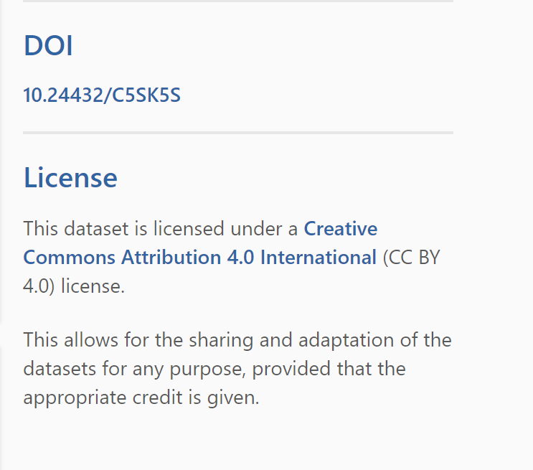

**Appendix 2:** Sample of patient’s reviews on drugs with the seven (7) features.

## 

## **Appendix 3:** Reading of the train and test datasets.

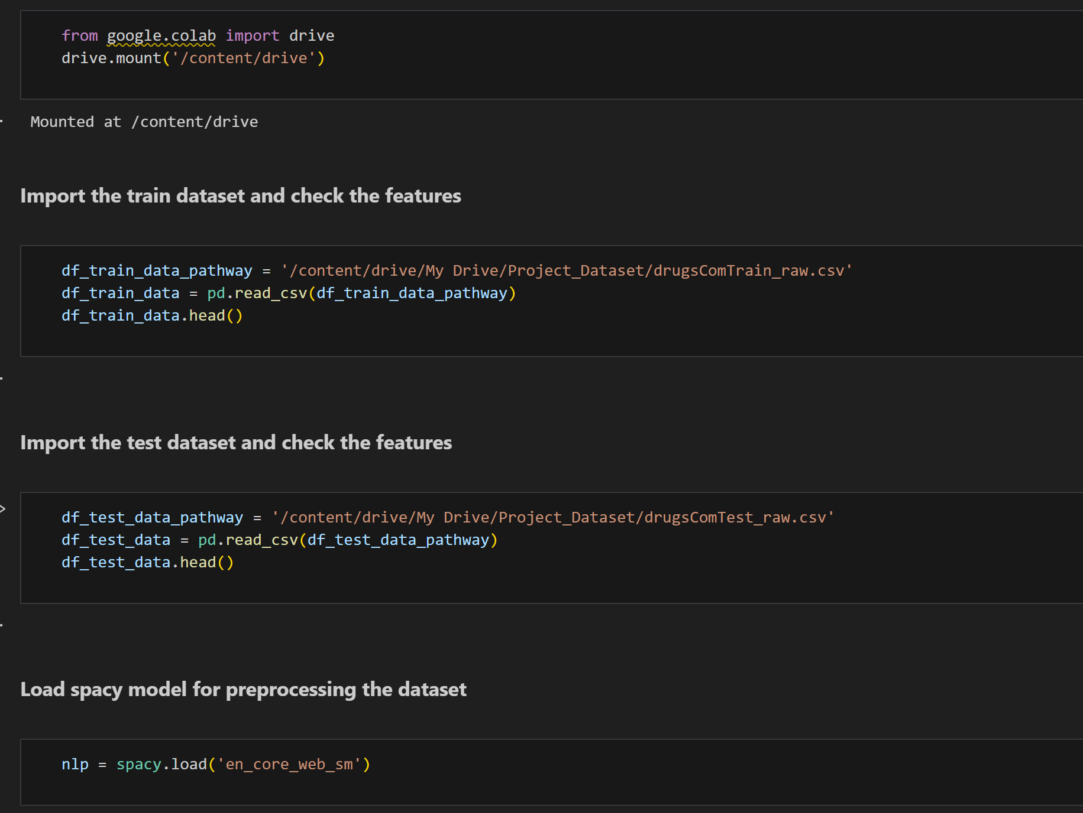

## **Appendix 4:** Charts to explore the data.

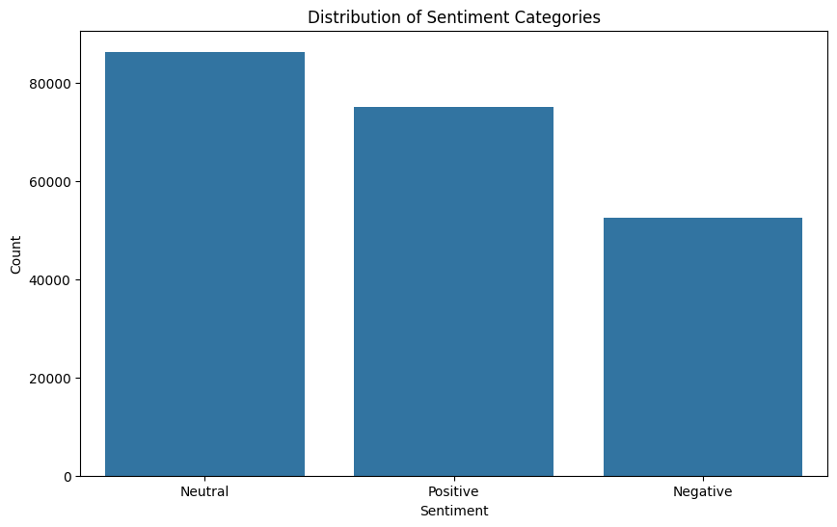

## **Appendix 5:** Top 10 words in positive and negative feedback

## **Appendix 6:** Positive and Negative feedback word cloud

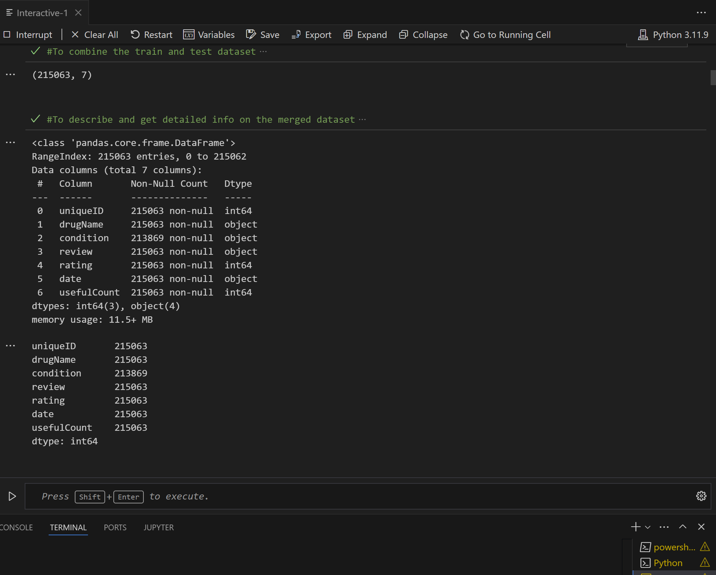

## **Appendix 7:** Merging of the train and test set

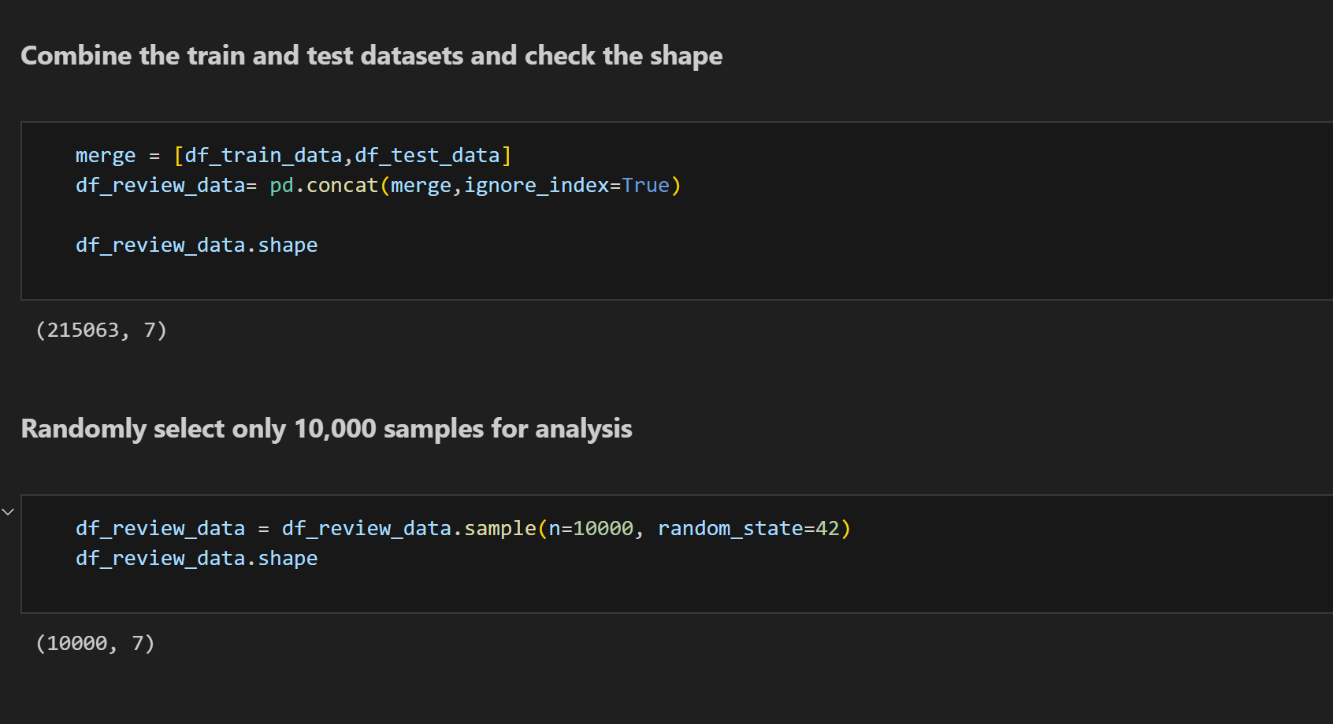

## **Appendix 8:** Code to perform data preprocessing.

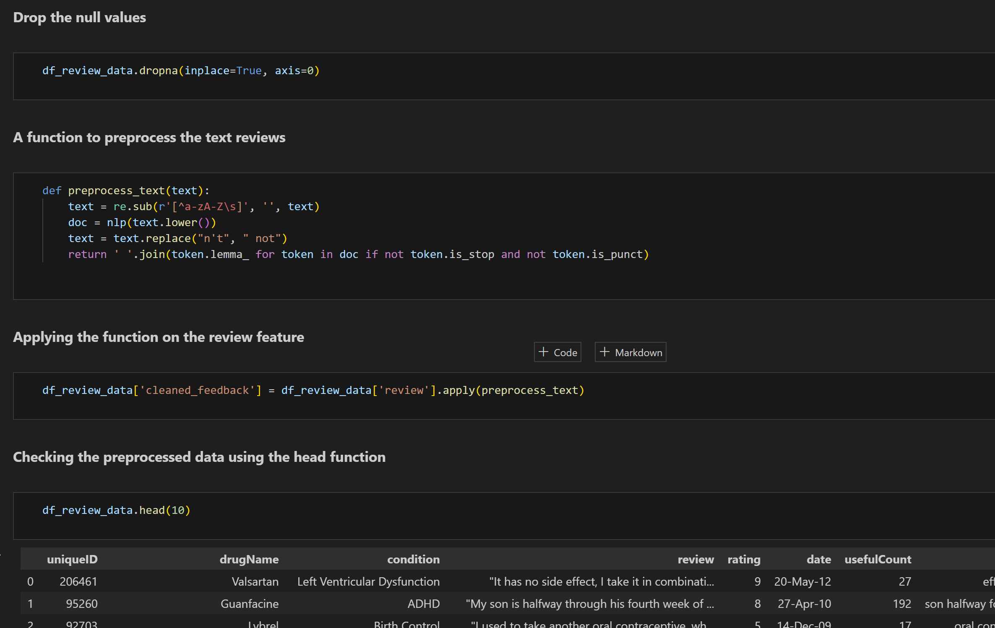

## **Appendix 9:** Code to perform feature engineering using TF-IDF Vectorizer

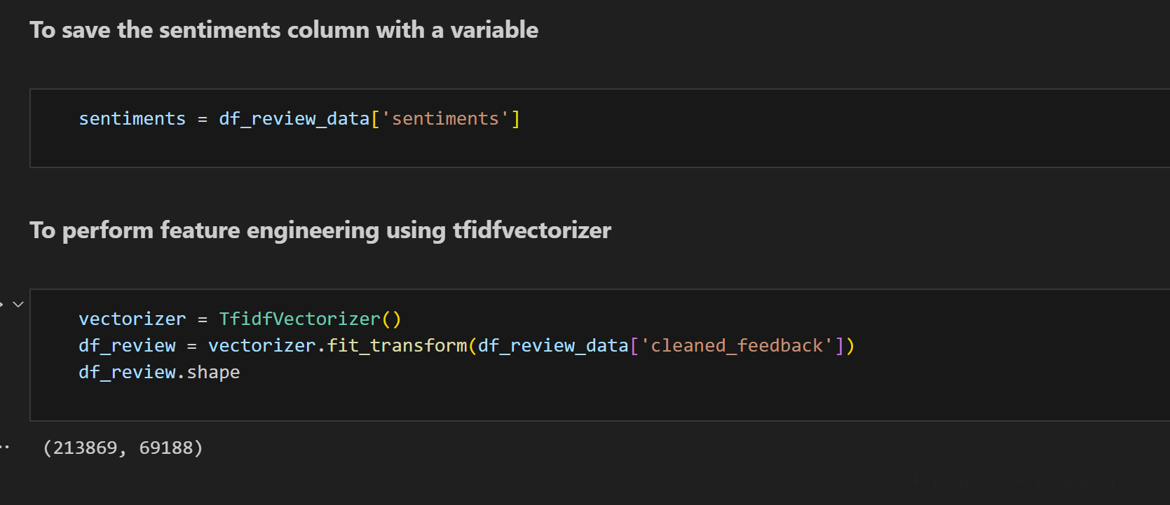

## **Appendix 10:** Splitting the data and Oversampling using SMOTE

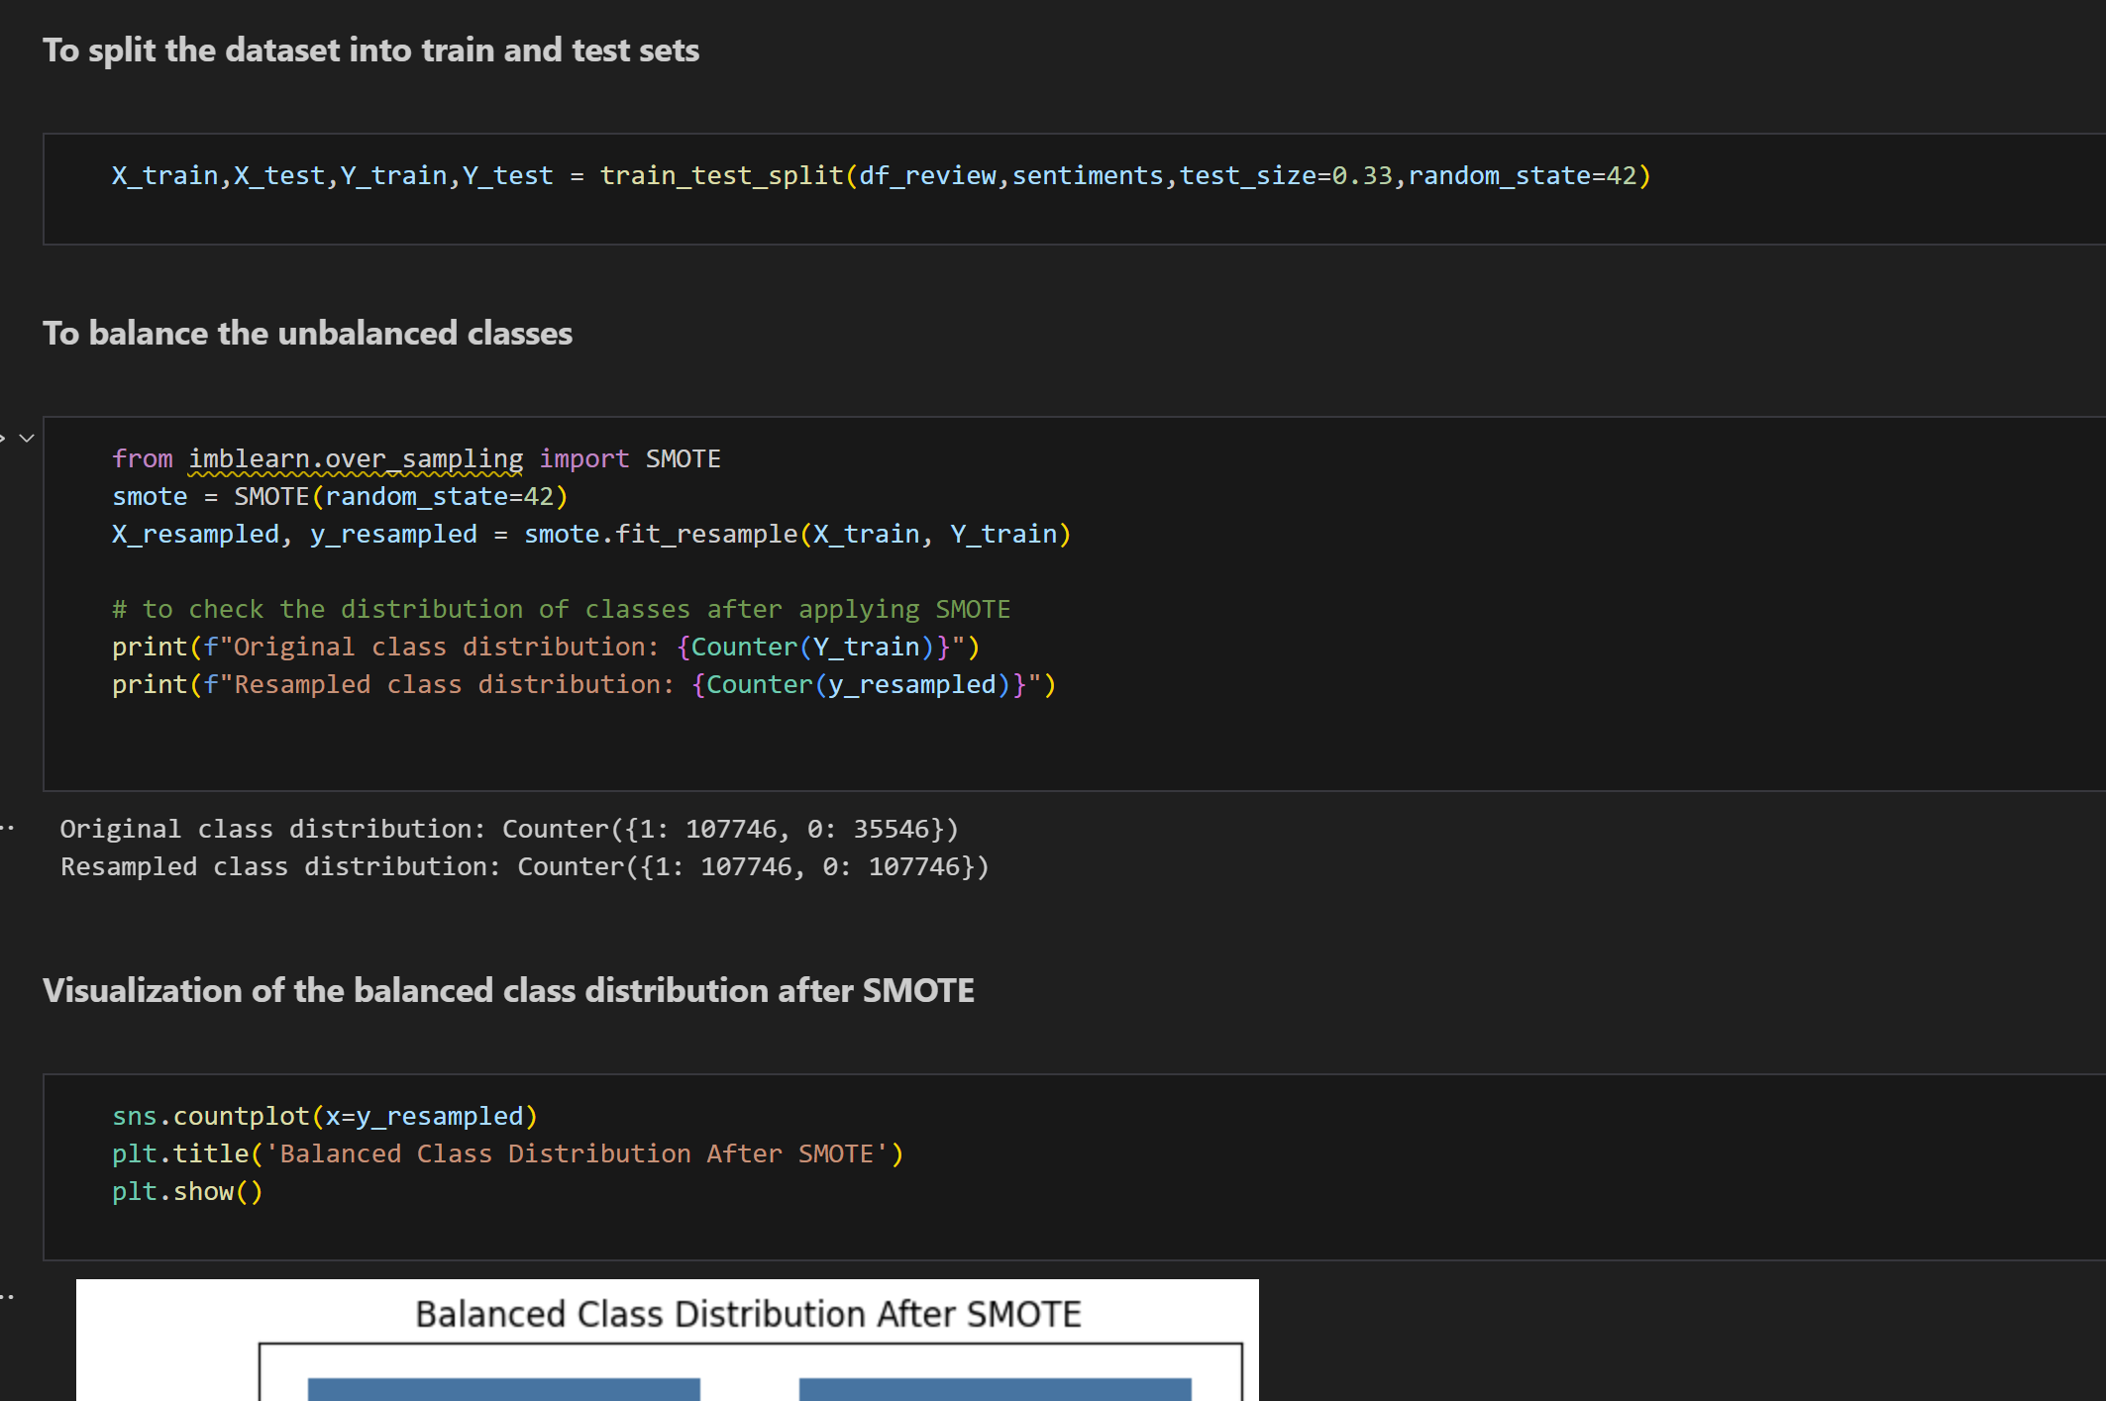

## **Appendix 11a:** Code for multinomial naïve bayes model from scratch.

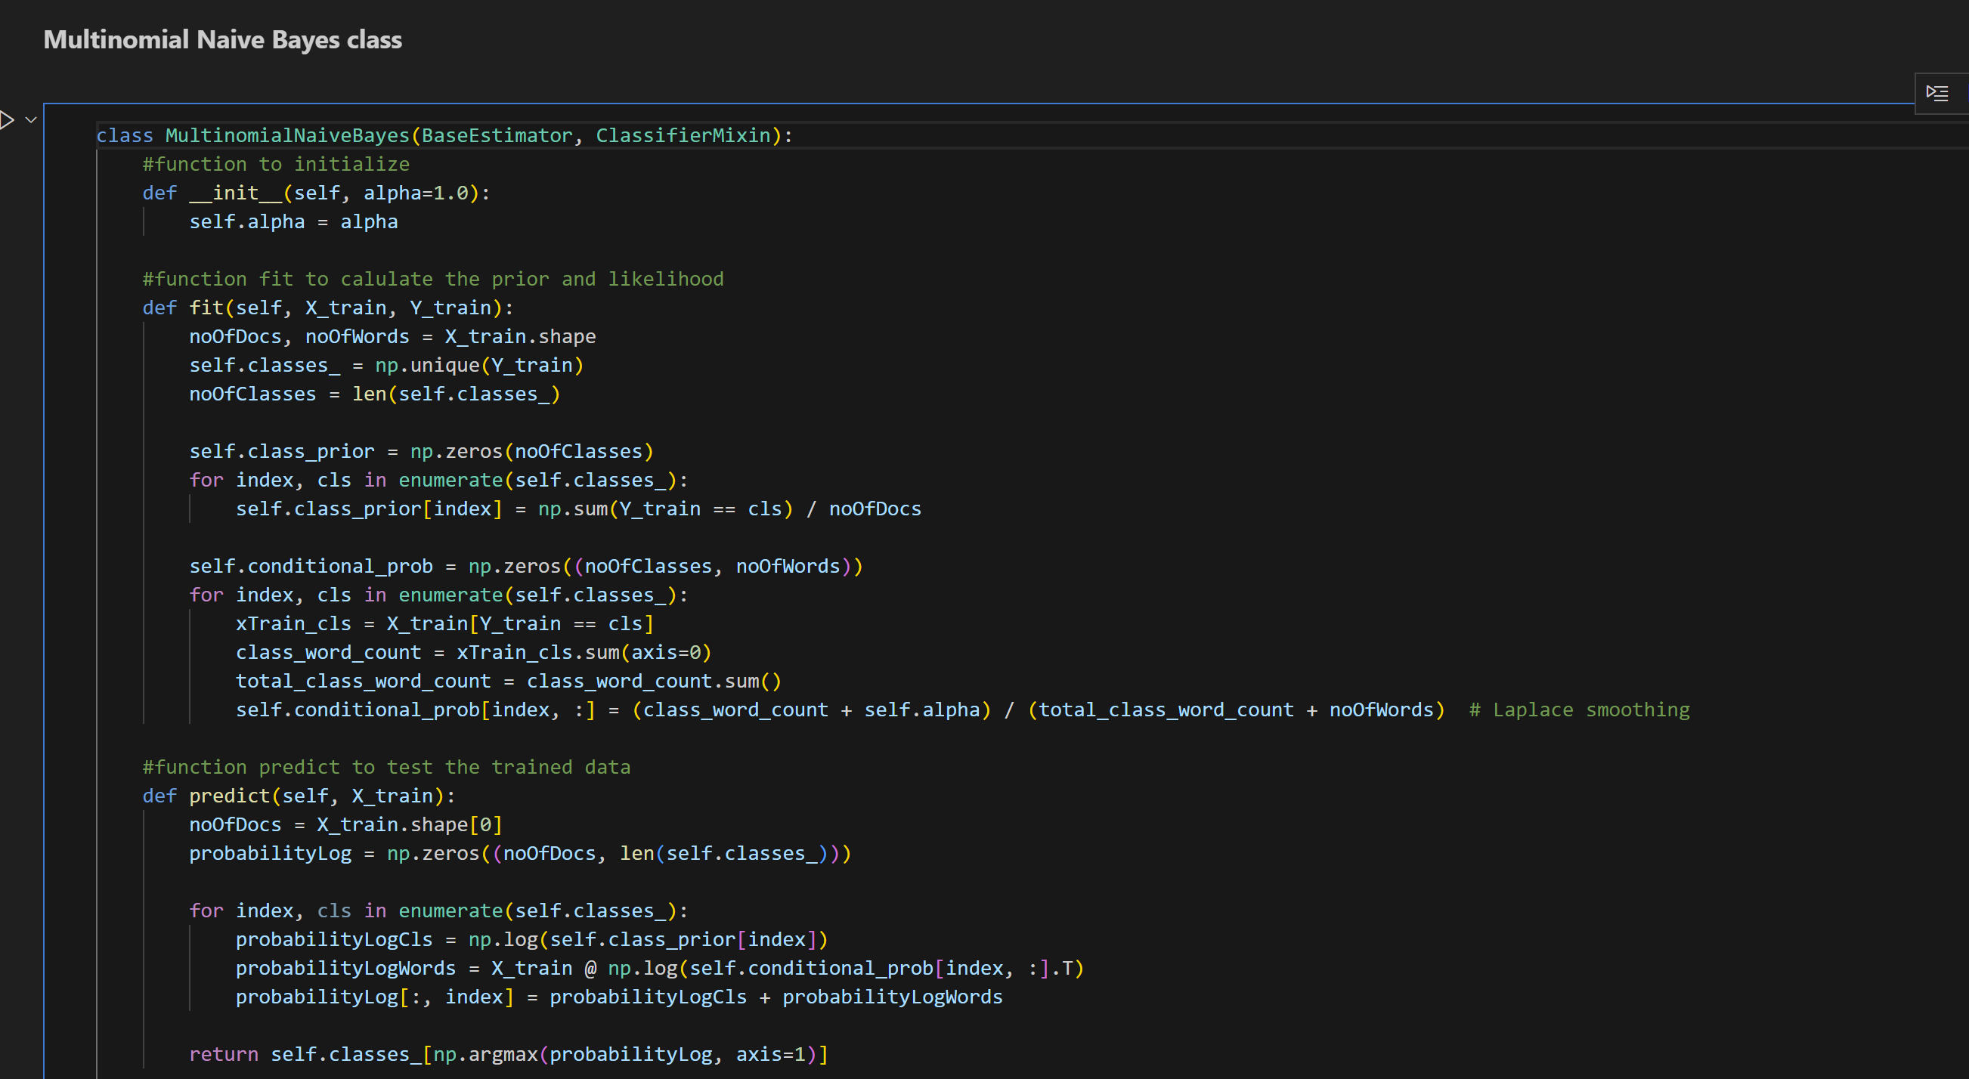

## **Appendix 11b:** Code for multinomial naïve bayes model from scratch contd.

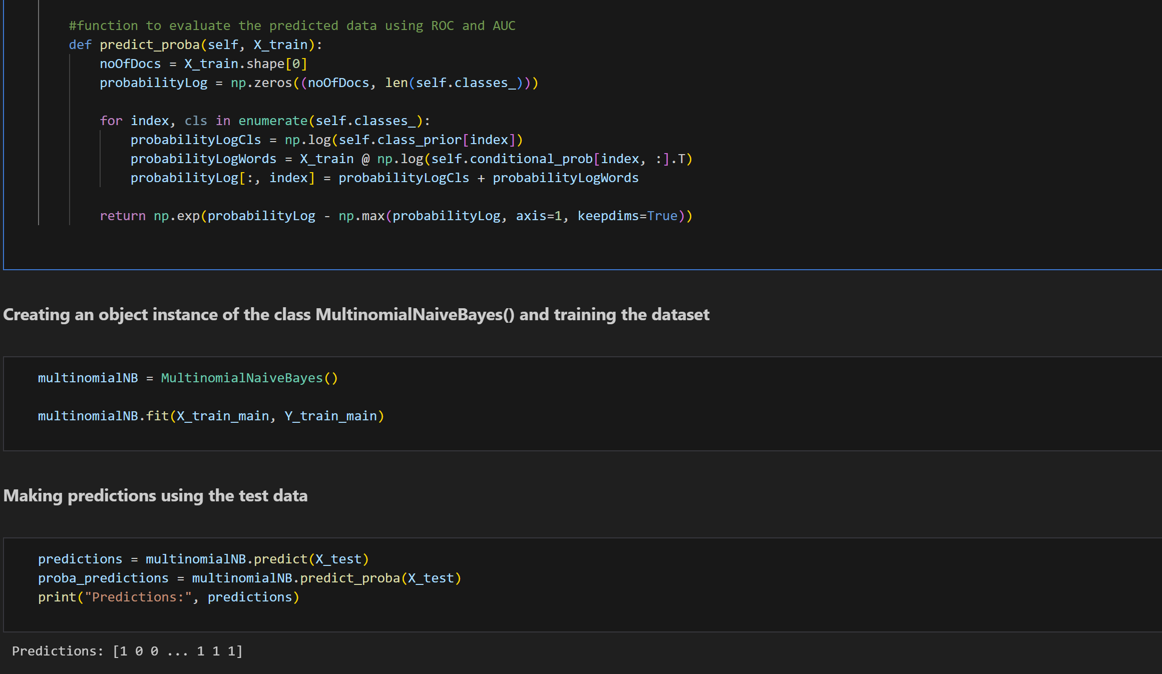

## **Appendix 13a:** Code for Random Forest Classifier model from scratch.

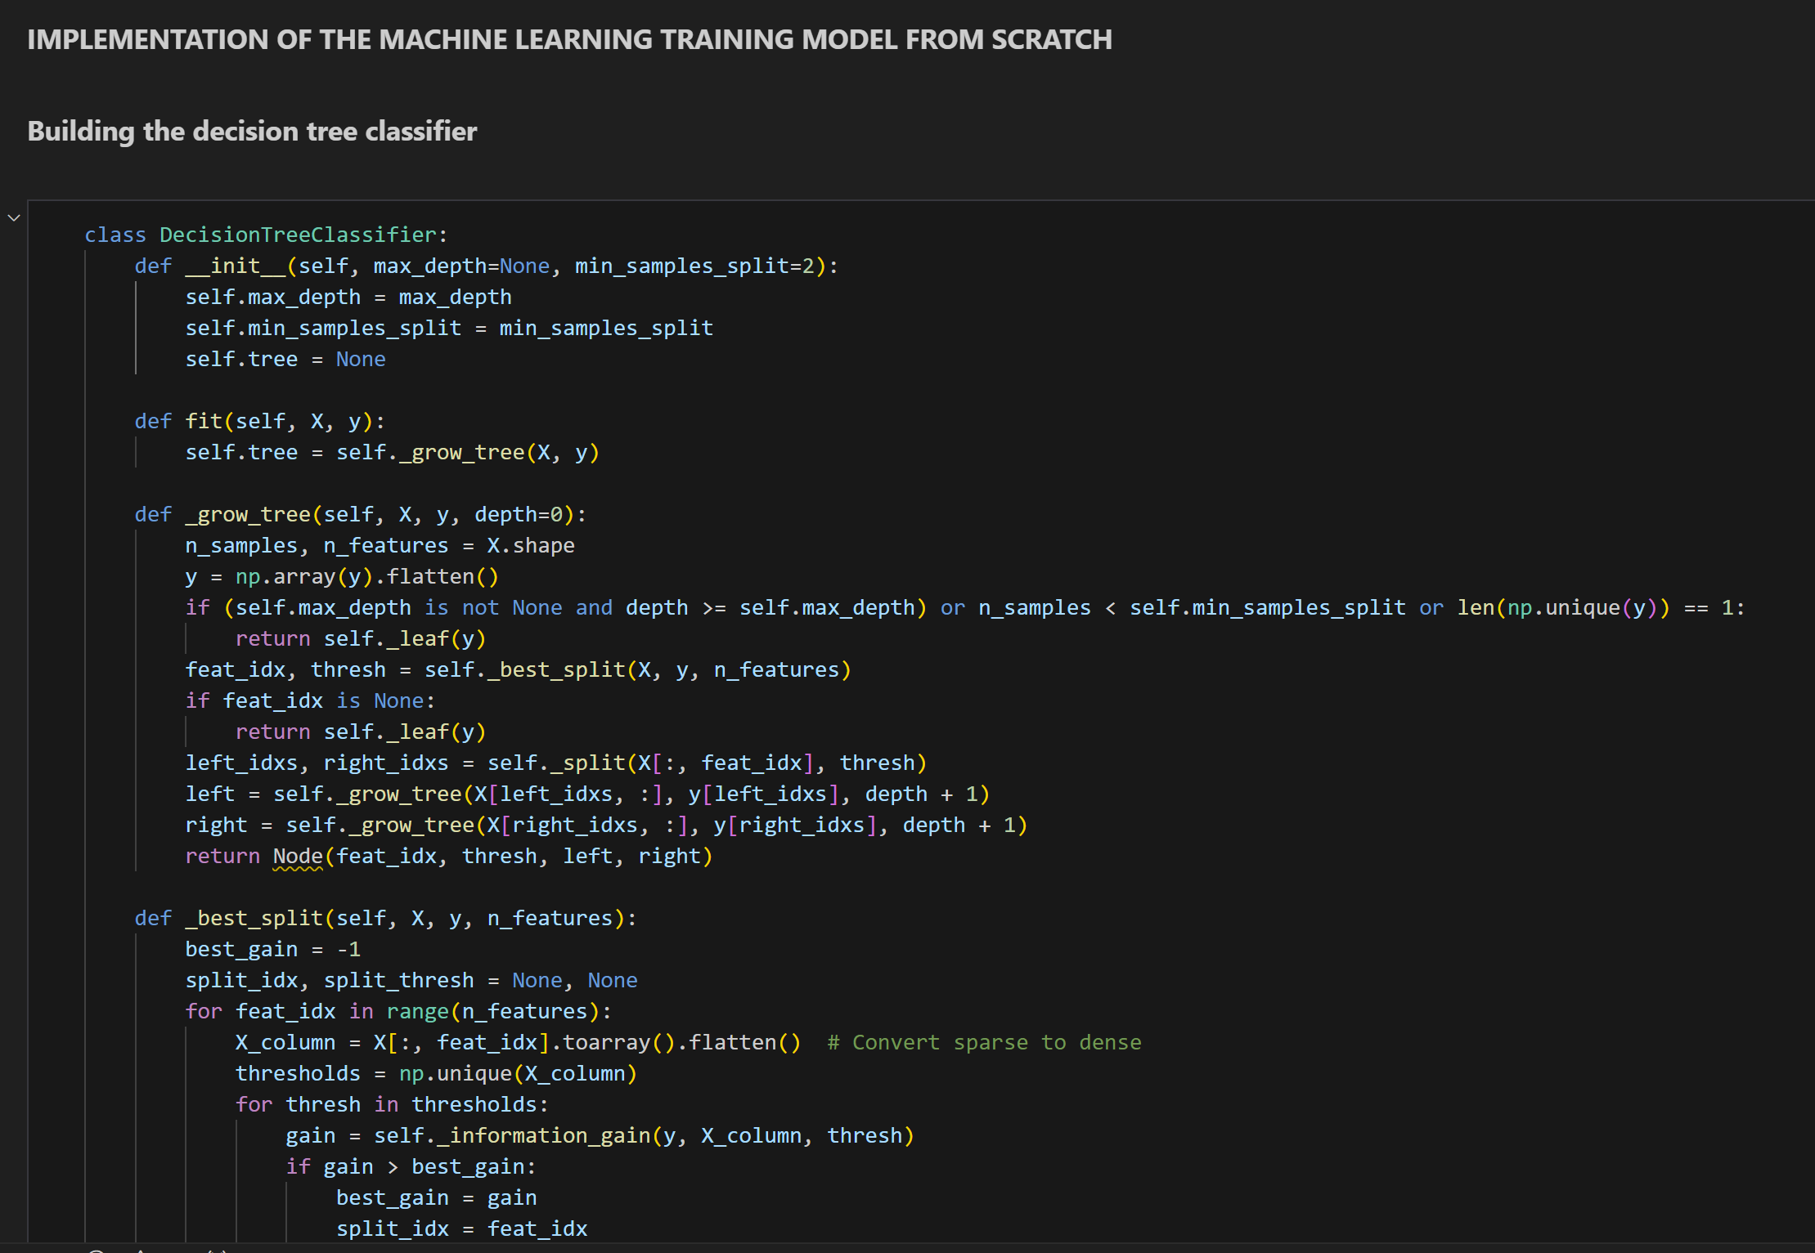

## **Appendix 13b:** Code for Random Forest Classifier model from scratch (contd).

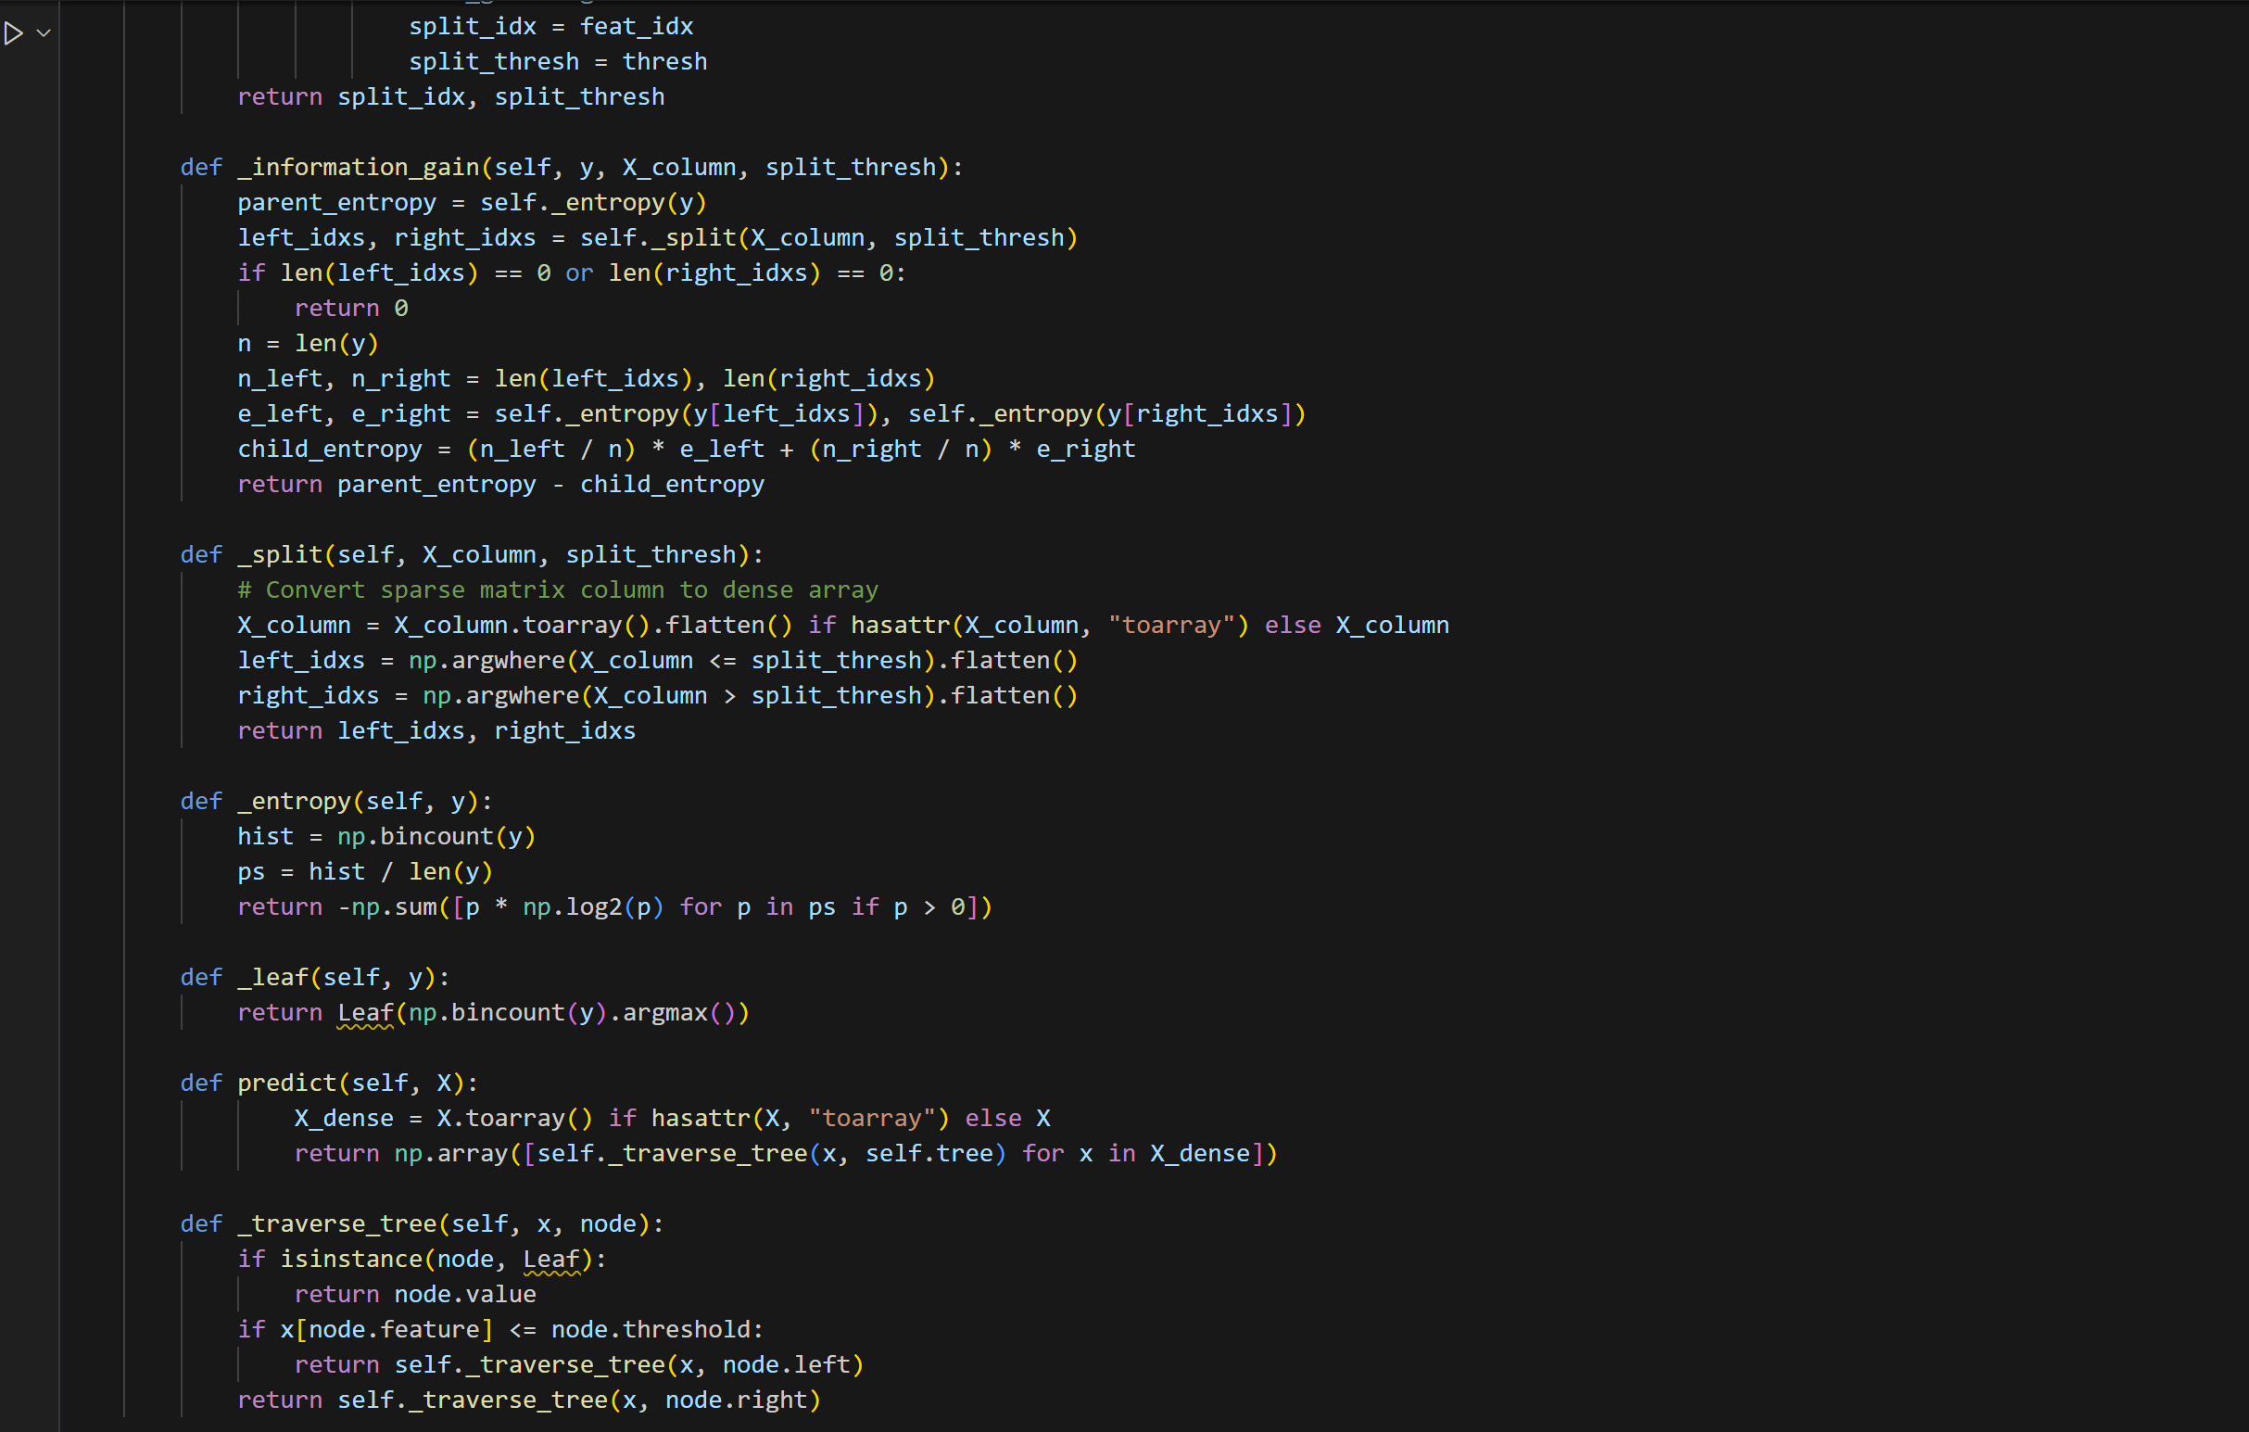

## **Appendix 13b:** Code for Random Forest Classifier model from scratch (contd).

